

**NAME:** K. Manoj Kumar

**REGISTER NUMBER:** 23MIS0159

**COURSE NAME:** Agile Development Process and DevOps Lab

**COURSE CODE:** ISWE406P

**SLOT:** L51+L52

**TASK 1: Jenkins Familiarization Objective:**

**Understand Jenkins UI and basic navigation**

**Tasks:**

**1. Open Jenkins Dashboard in browser**

**2. Identify:**

**o Dashboard**

**o Manage Jenkins**

**o New Item**

**o Build History**

**3. Check Jenkins version**

**Expected Output:**

**Screenshot or note of Jenkins version**

**DASHBOARD, Jenkins Version:**

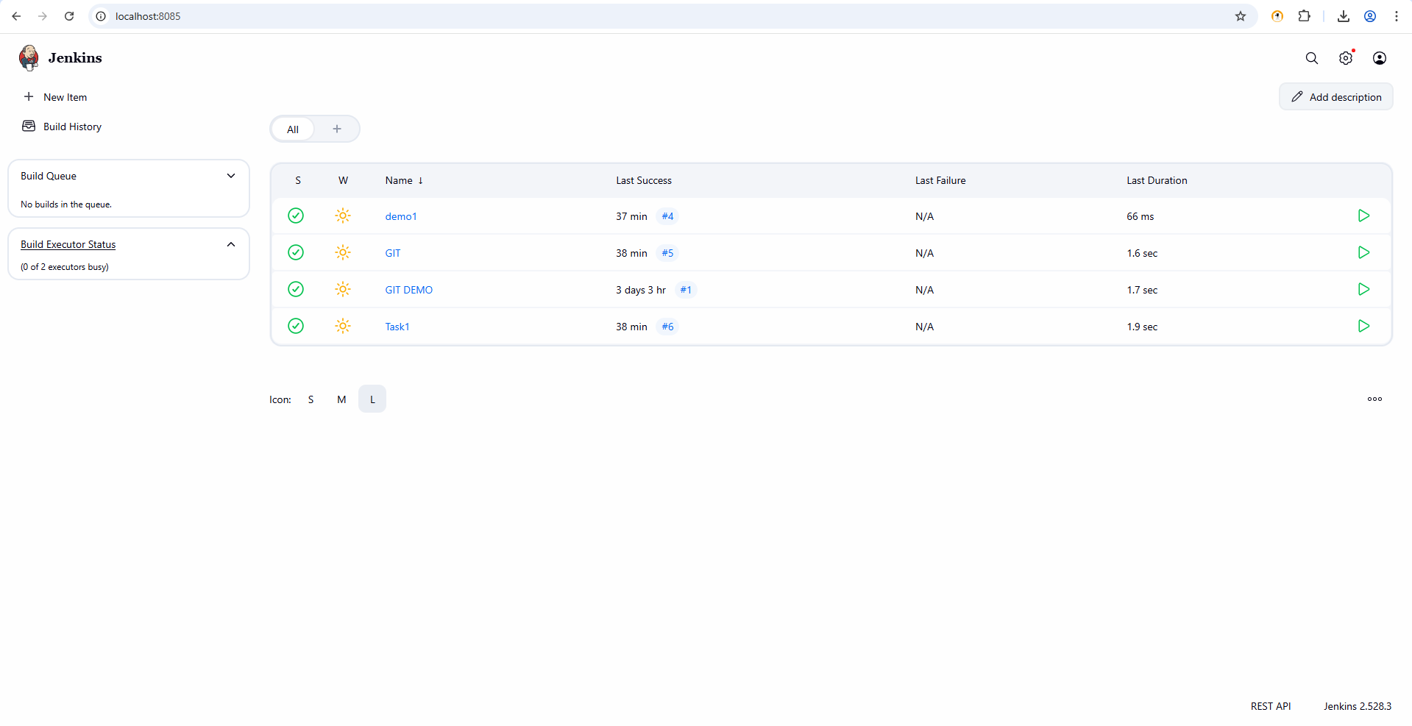

**NEWITEMS:**

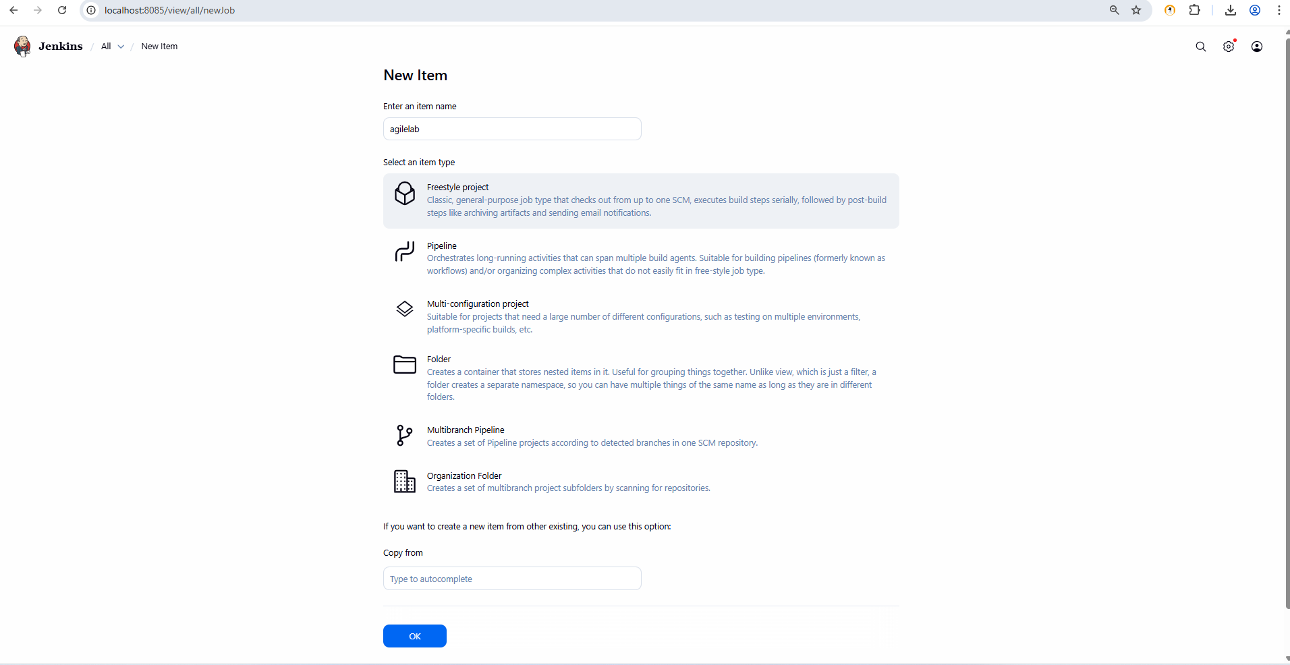

**Build History:**

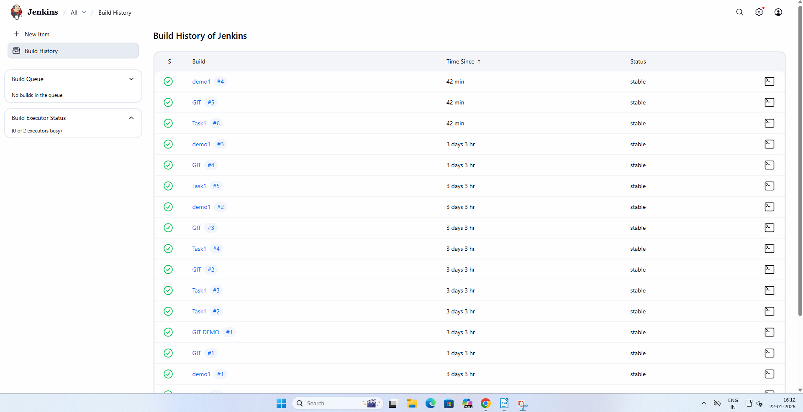

**MANAGE JENKINS:**

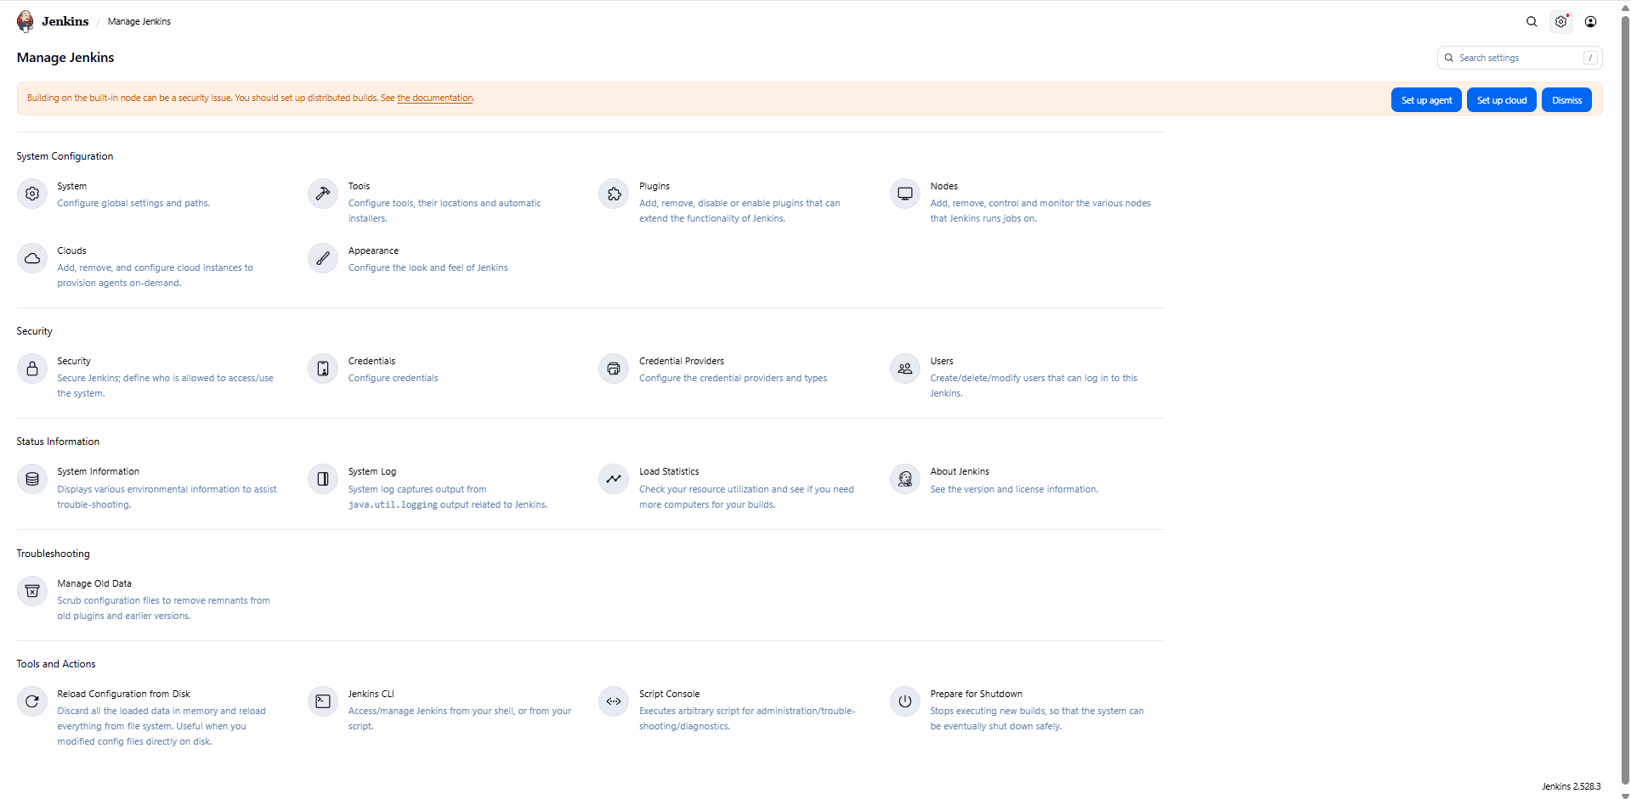

**TASK 2: Create First Freestyle Job**

**Objective:**

**Create and run a Jenkins job**

**Tasks:**

1. **Create a Freestyle project named Hello-Jenkins**

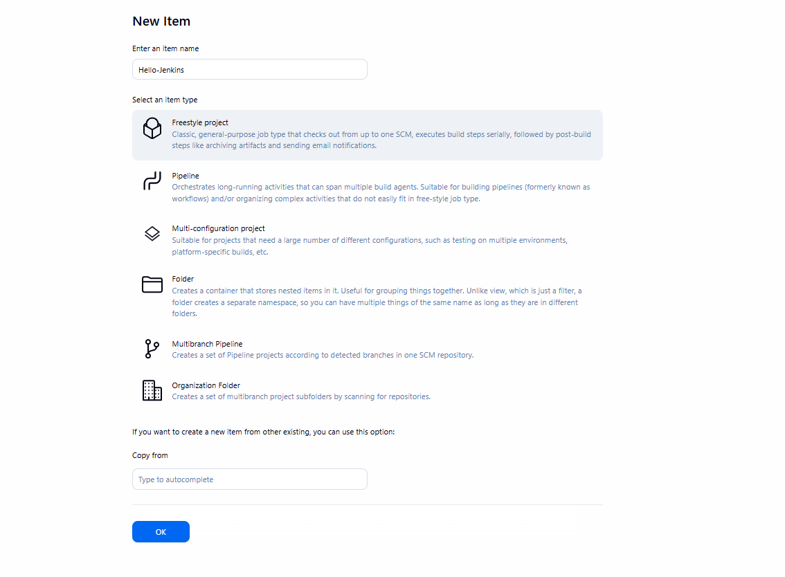

**2. Add a description**

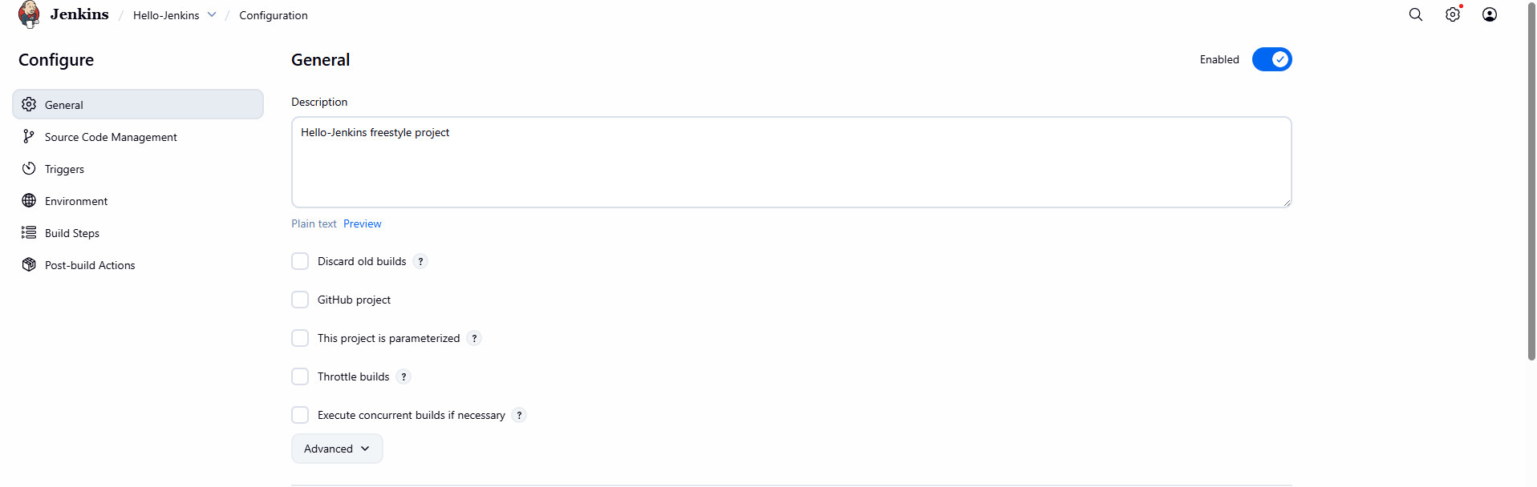

**3. Add build step: o Execute shell / Windows batch command o Print "Hello Jenkins"**

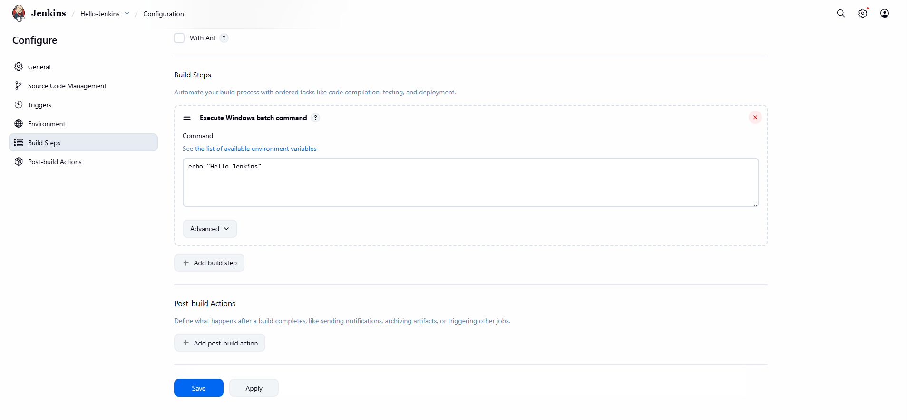

**4. Build the job manually**

**Expected Output: Console output showing message**

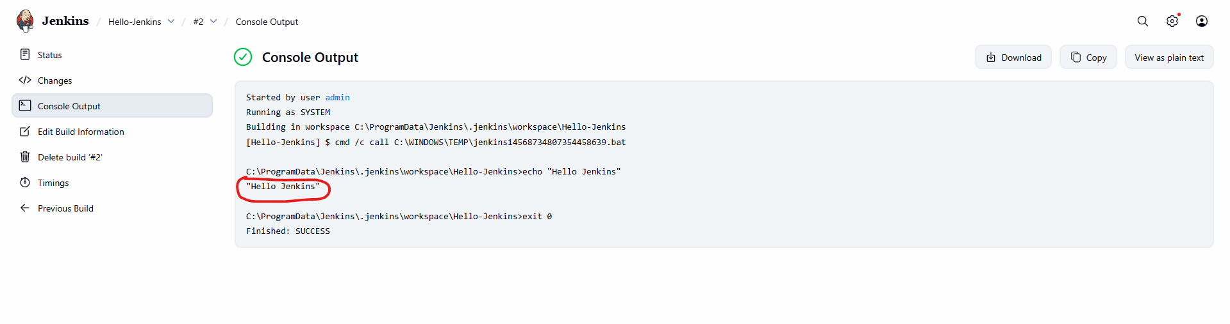

**TASK 3: Jenkins Workspace & Commands**

**Objective: Understand workspace usage**

**Tasks:**

1. **Navigate to job workspace**

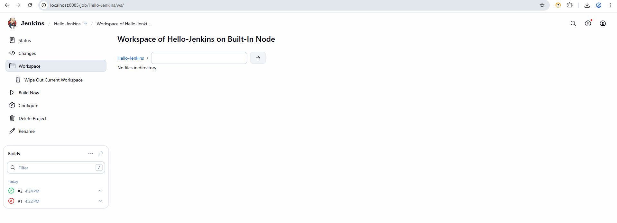

**2. Create a text file using build step**

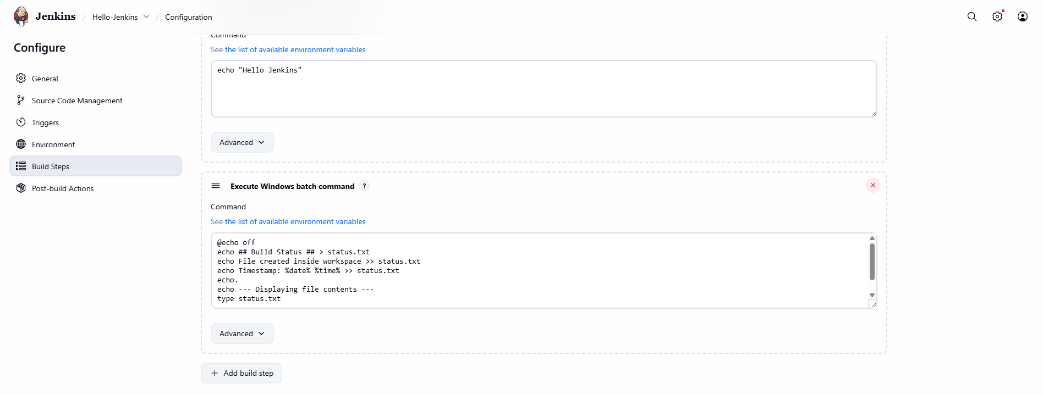

**3. Display file contents in console**

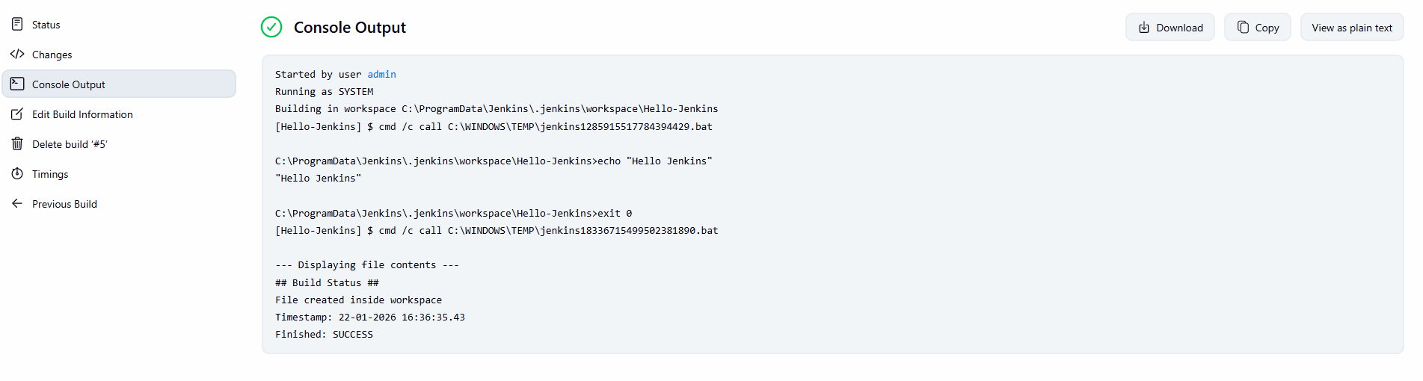

**Expected Output: File created inside workspace**

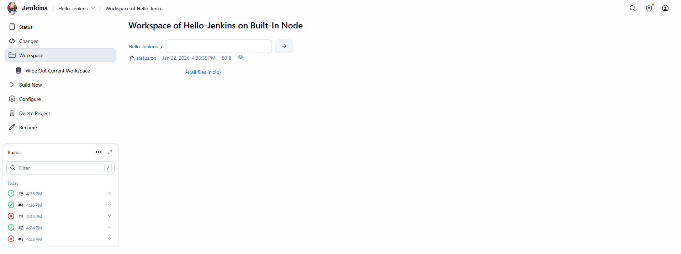

**TASK 4: Git Integration**

**Objective: Integrate Jenkins with GitHub**

**Tasks: 1. Create a GitHub repository with sample code**

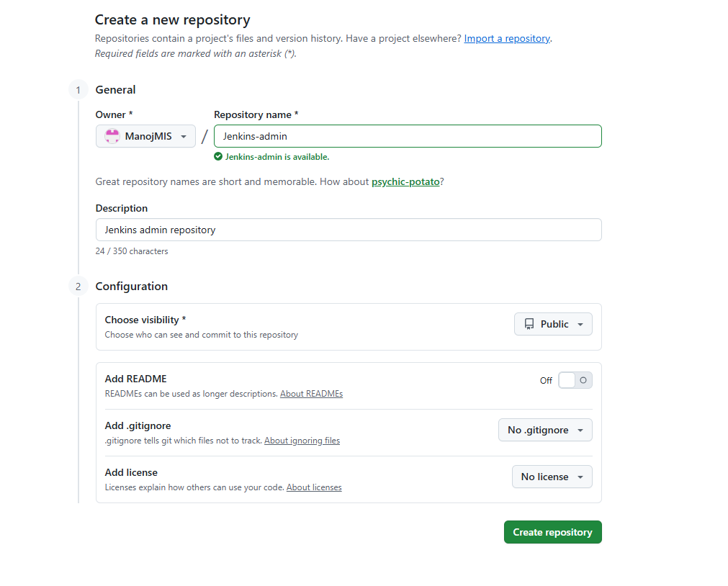

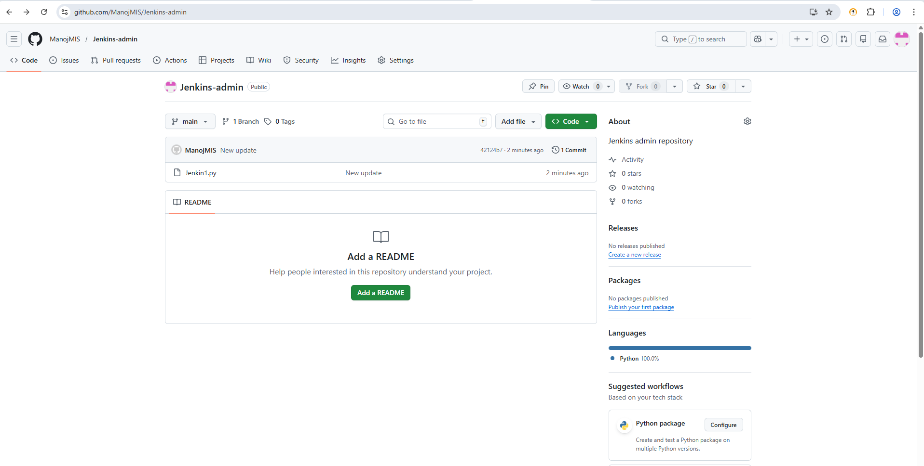

**2. Configure Git in Jenkins**

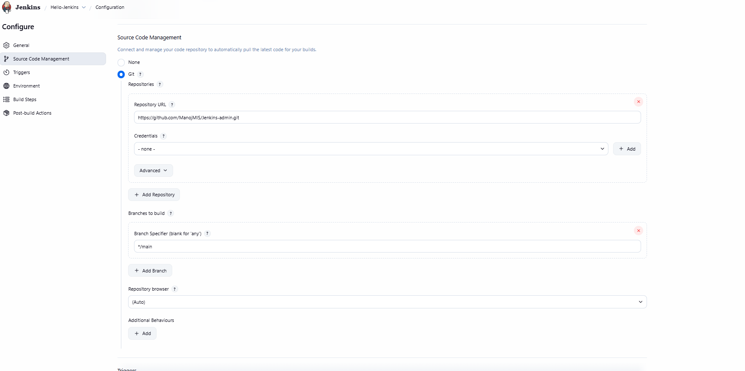

**3. Add Git repository URL in job**

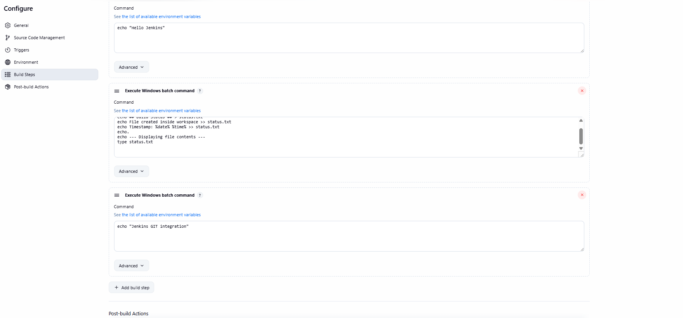

**4. Build and verify code checkout**

**Expected Output: Source code visible in workspace**

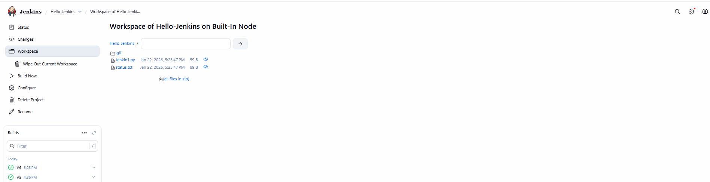

**TASK 5: Poll SCM Trigger**

**Objective: Automatically trigger builds on code change**

**Tasks: 1. Enable Poll SCM**

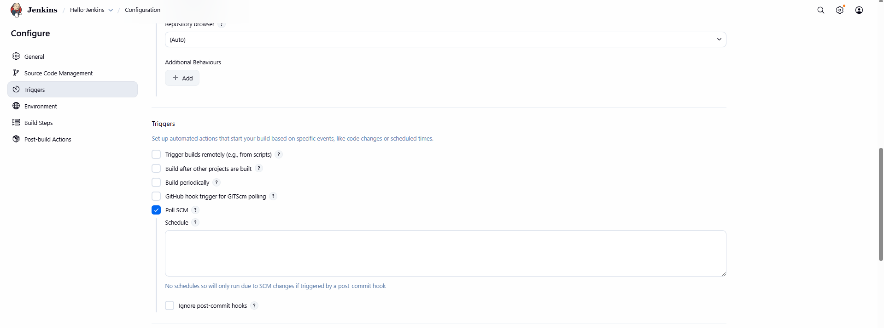**2. Set schedule: * * * * \***

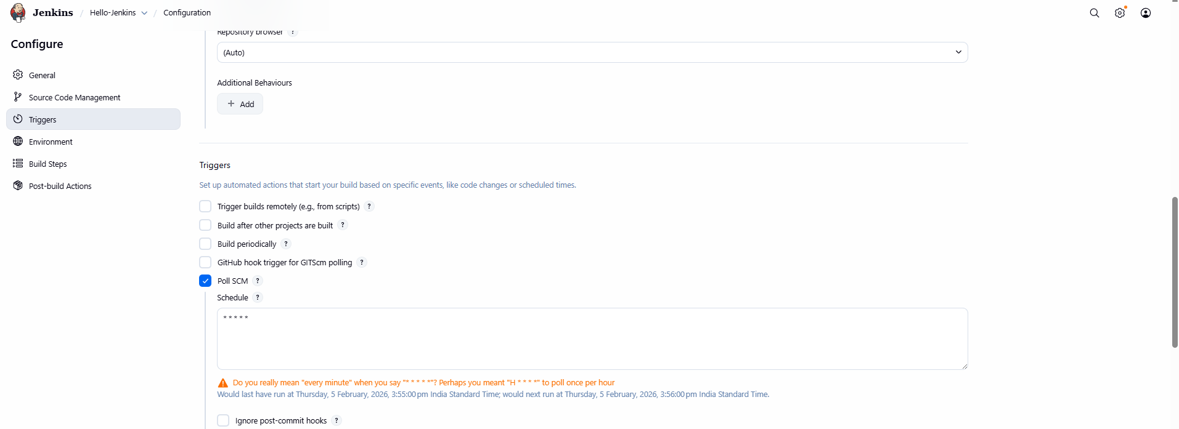

**3. Modify GitHub file and commit**

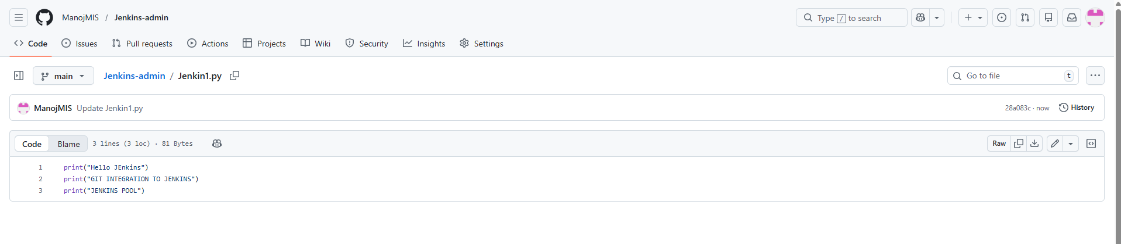

**4. Observe automatic build Expected Output: • Build triggered without manual action**

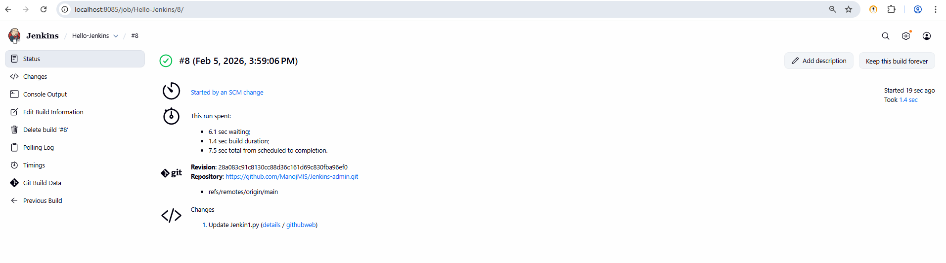

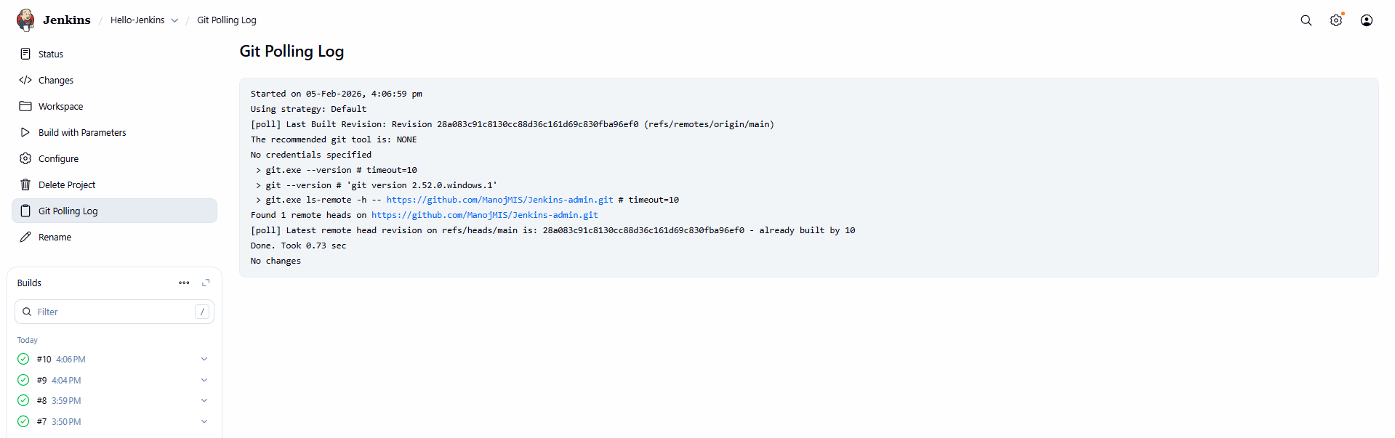

**TASK 6: Parameterized Build**

**Objective: Use parameters in Jenkins job**

**Tasks: 1. Enable parameterized build**

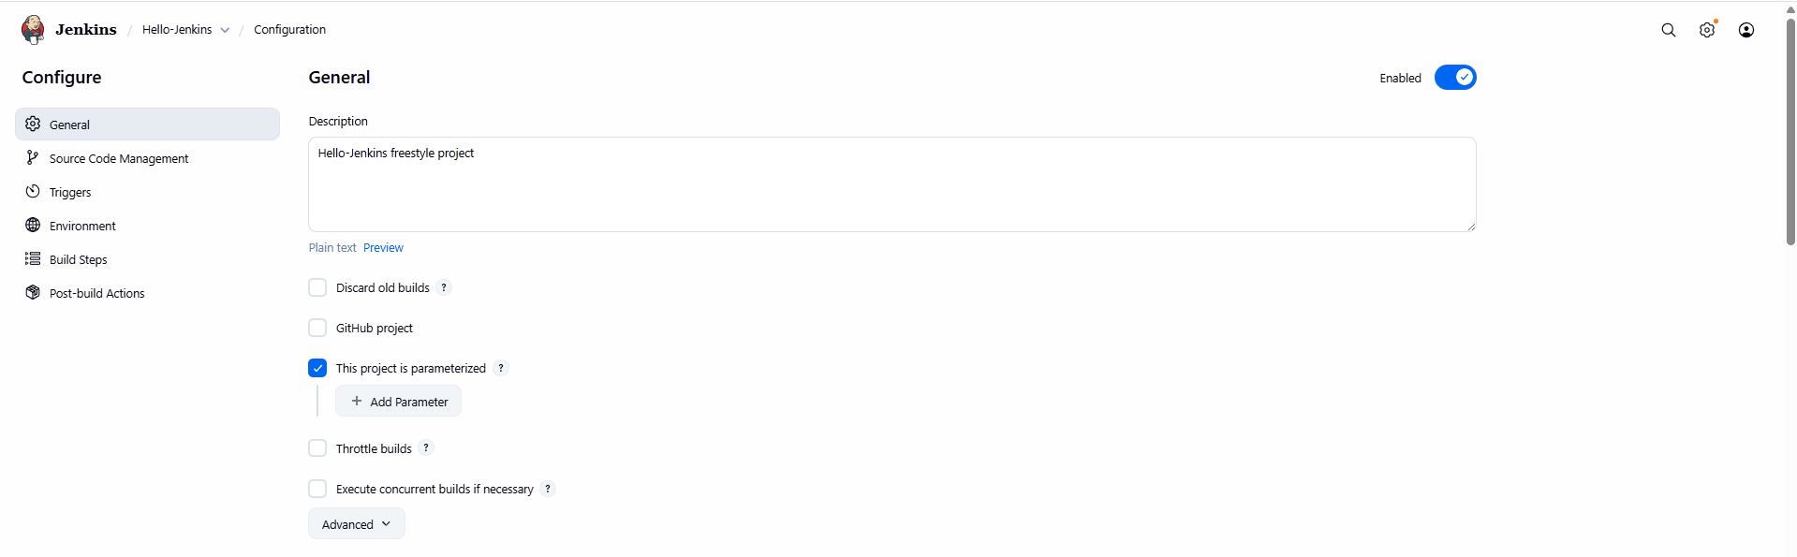

**2. Add String parameter USERNAME**

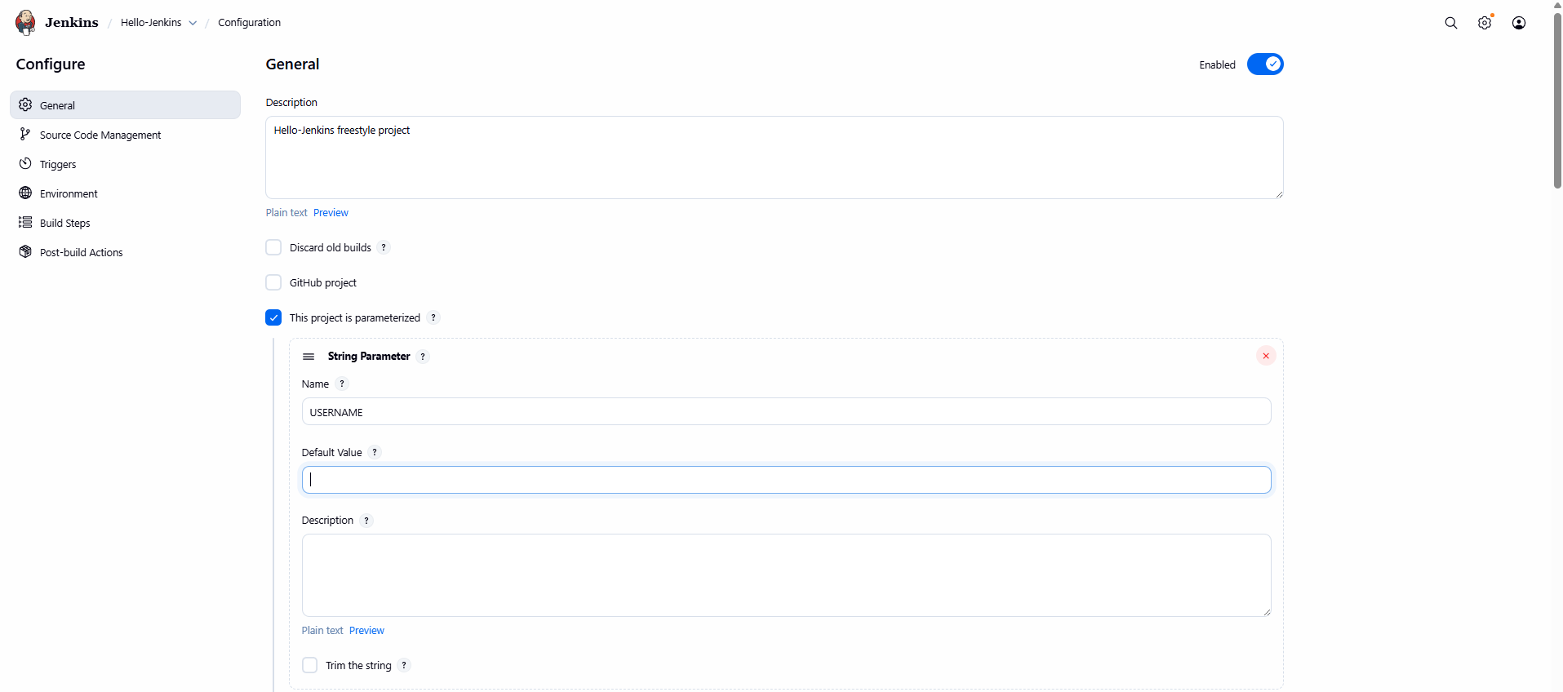

**3. Print parameter value in build step Expected Output: • Console output showing parameter value**

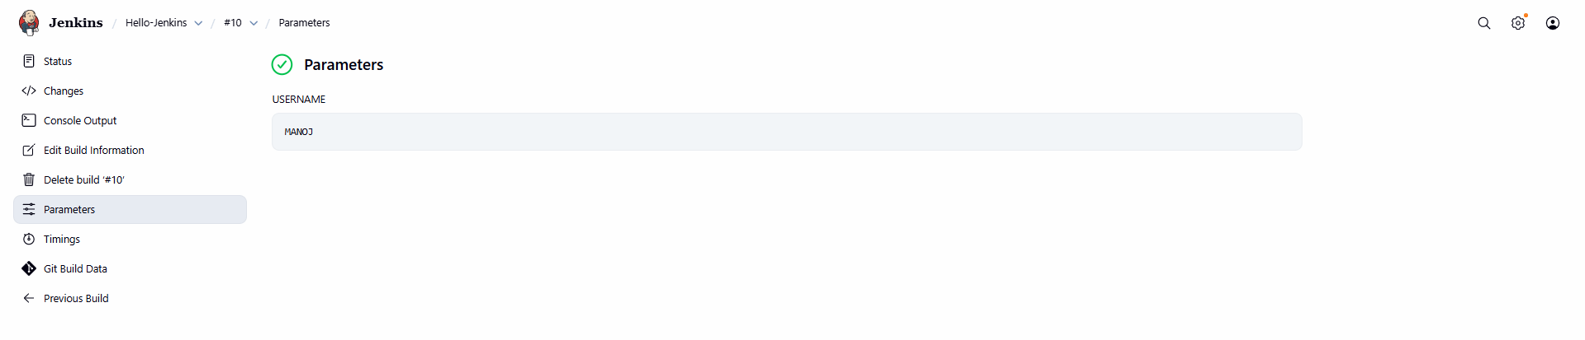

**TASK 7: Java Build Using Jenkins**

**Objective: Compile Java program using Jenkins**

**Tasks: 1. Create simple Hello.java**

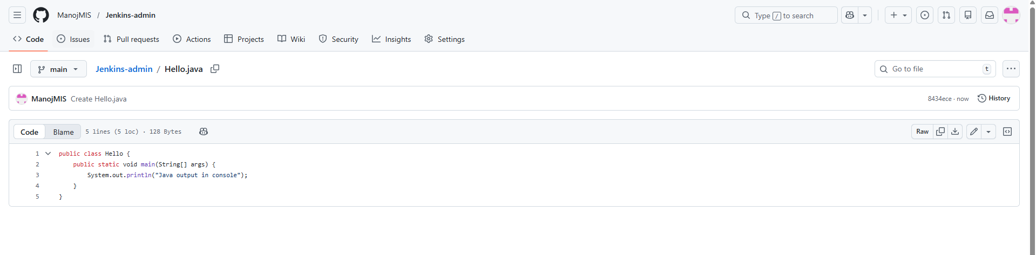**2. Compile using javac**

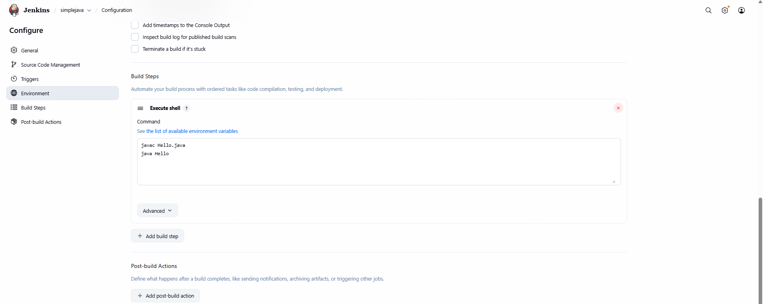

**3. Run Java program Expected Output: • Java output in console**

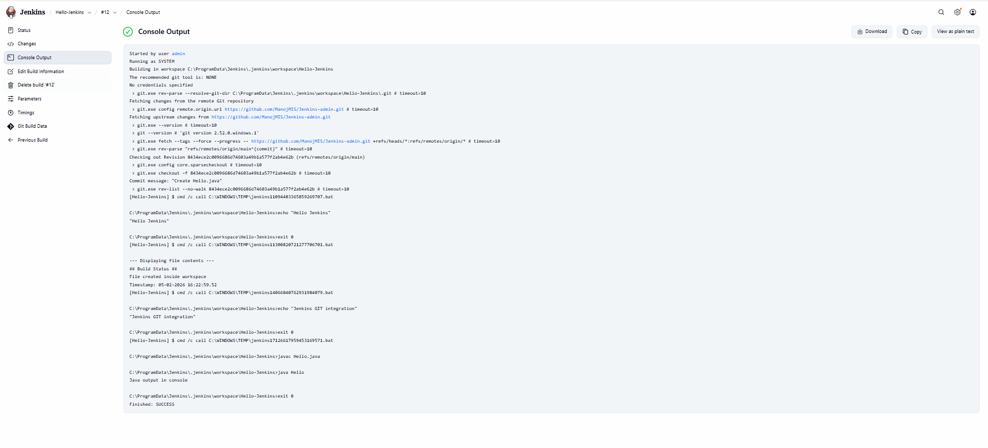

**TASK 8: Archive Artifacts**

**Objective: Store build outputs**

**Tasks: 1. Generate .class or .jar file**

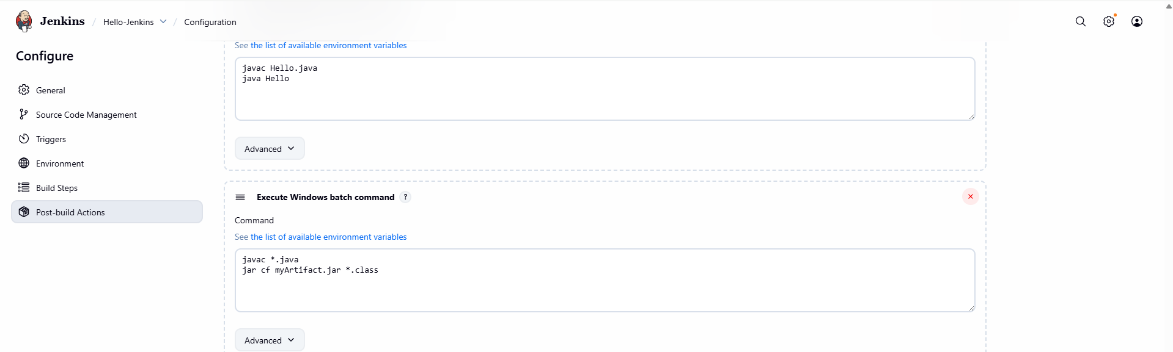

**2. Archive artifacts in post-build action**

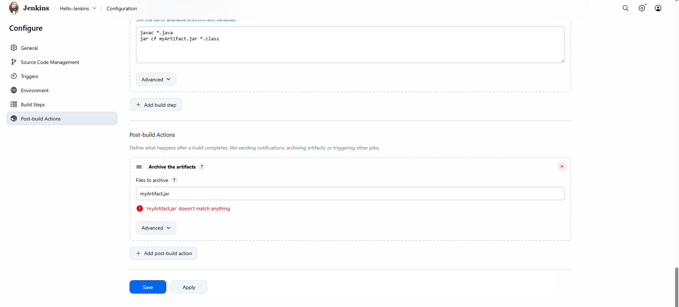

**3. Download artifact from Jenkins UI Expected Output: • Artifact available for download**

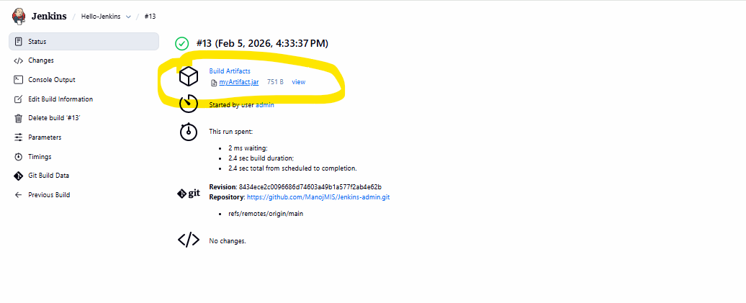

**TASK 9: Users & Roles**

**Objective: Manage Jenkins users**

**Tasks: 1. Create two users**

**2. Assign read-only permission to one user**

**3. Assign build permission to another user Expected Output: • Permission differences verified**

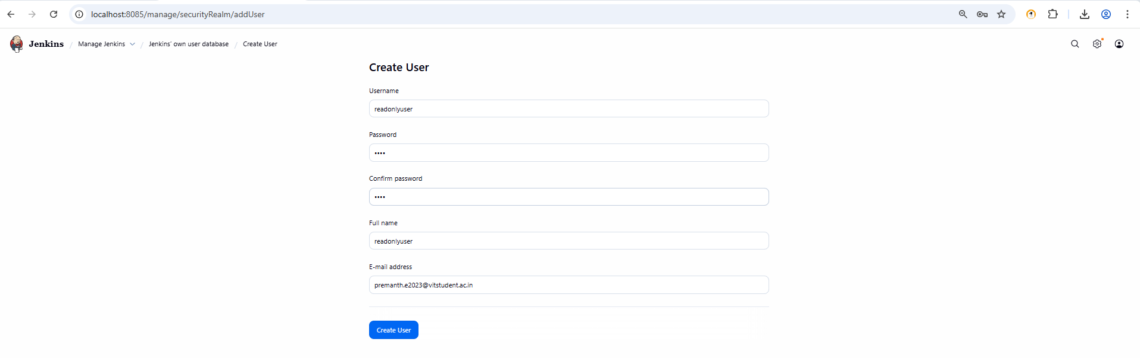

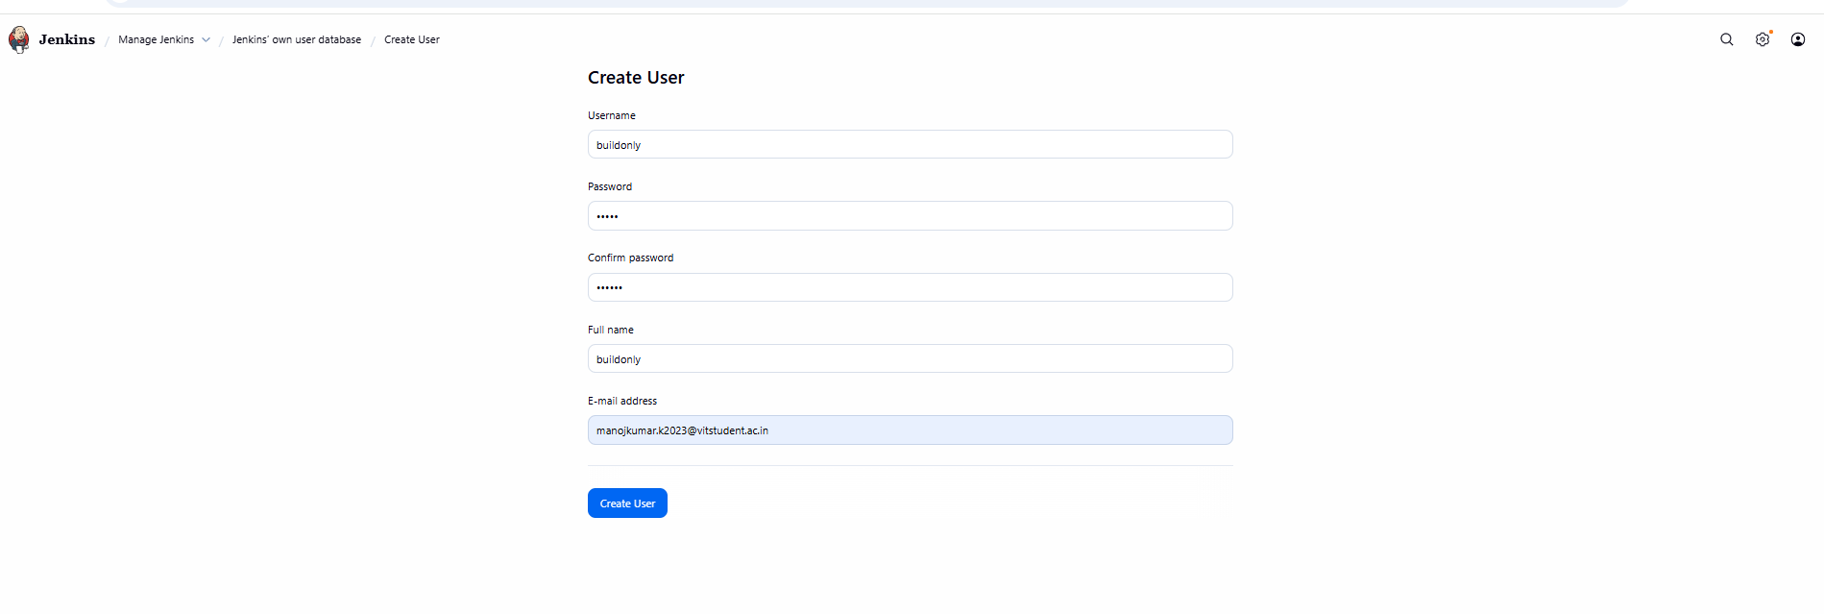

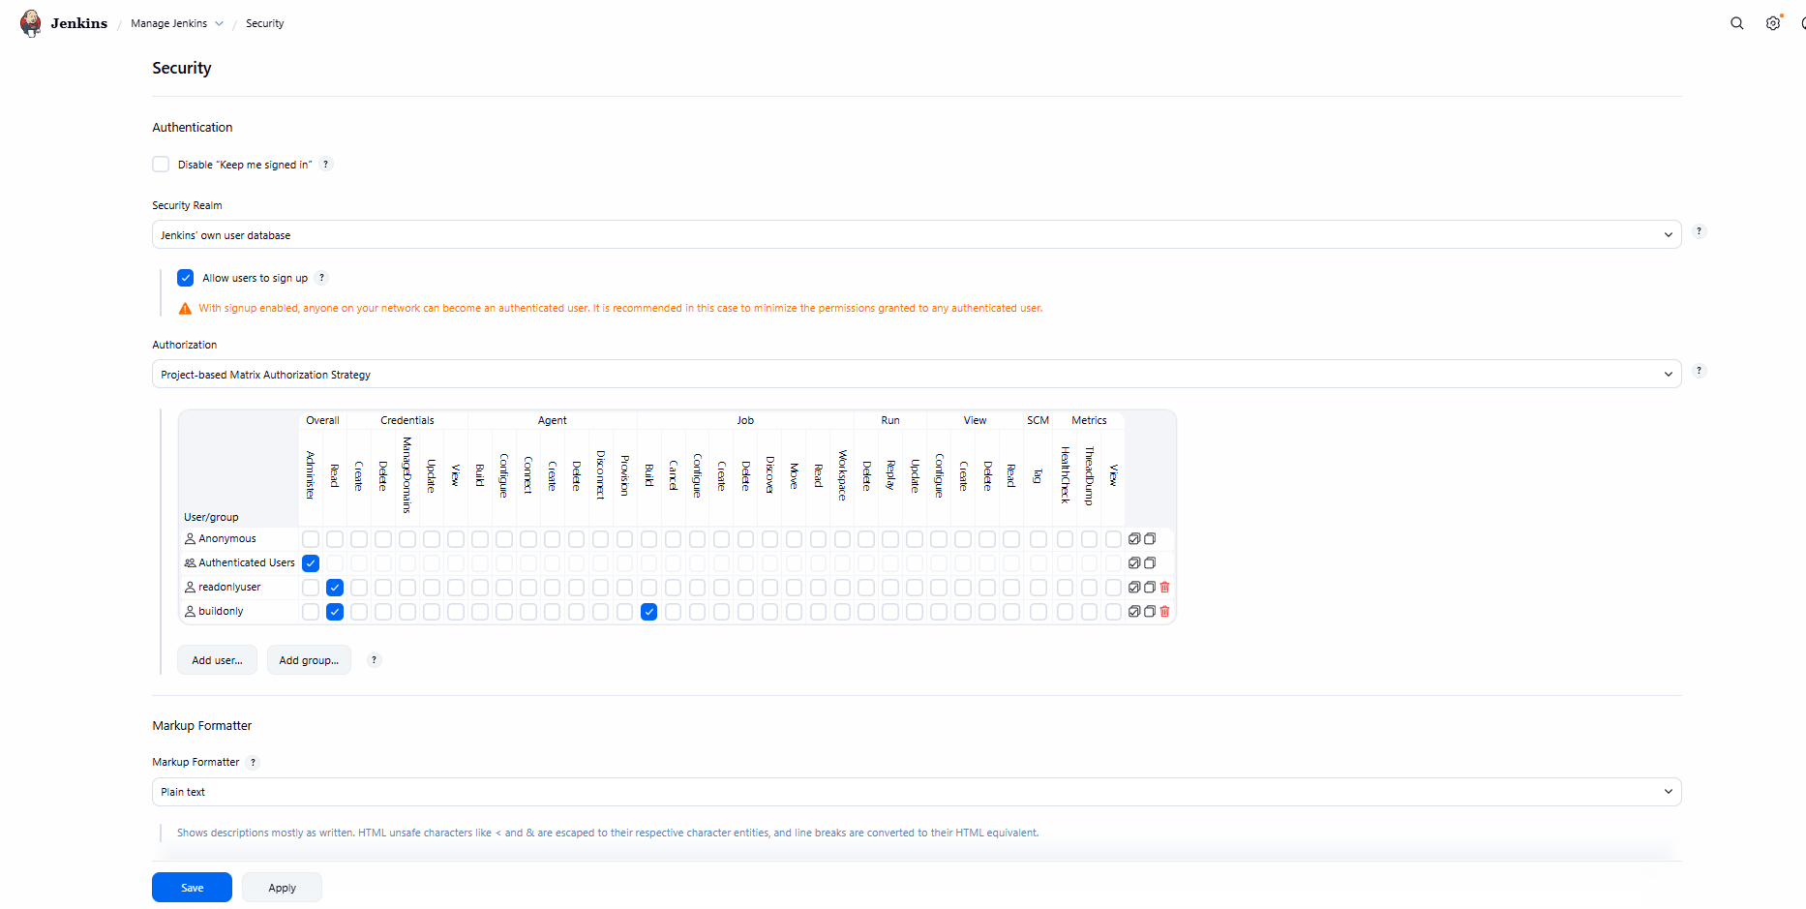

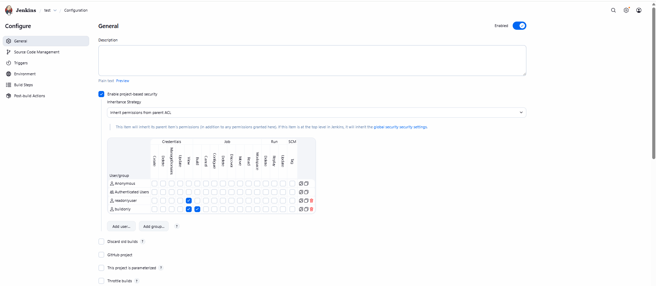

**DESCRIPTION:PIPELINES WERE NOT TAUGHT SO MAM ANNOUNCED TO DO TASKS TILL 9 and from 10 to 15 related to pipeline not required**

**TASK 10: Simple Jenkins Pipeline**

**Objective: Create basic pipeline**

**Tasks: 1. Create Pipeline job**

**2. Write pipeline with stages: o Checkout o Build o Test**

**3. Run pipeline Expected Output: • Pipeline stage view**

**TASK 11: Jenkinsfile from Git**

**Objective: Pipeline as Code**

**Tasks: 1. Create Jenkinsfile in Git repo**

**2. Configure pipeline from SCM**

**3. Trigger build Expected Output: • Pipeline executed from Git**

**TASK 12: Post-Build Actions**

**Objective: Handle build result**

**Tasks: 1. Add post section**

1. **Print message on success/failure Expected Output:** • **Appropriate message displayed**

**TASK 13: Trigger Job from Another Job**

**Objective: Job chaining**

**Tasks: 1. Create Job-A and Job-B**

1. **Configure Job-B to trigger after Job-A Expected Output:** • **Job-B triggered automatically**

**TASK 14: Workspace Cleanup**

**Objective: Manage disk usage**

**Tasks: 1. Install Workspace Cleanup plugin**

1. **Clean workspace before build Expected Output:** • **Workspace cleared before execution TASK**

**15: Mini CI Project**

**Objective: Implement basic CI flow**

**Tasks: 1. Git commit → Jenkins build**

**2. Compile code**

**3. Archive artifacts**

**4. Fail build on error Expected Output:** • **Automated CI pipeline**

**TOOL:GIT ACTIONS**

**1.)GIT ACTIONS DASBOARD:**

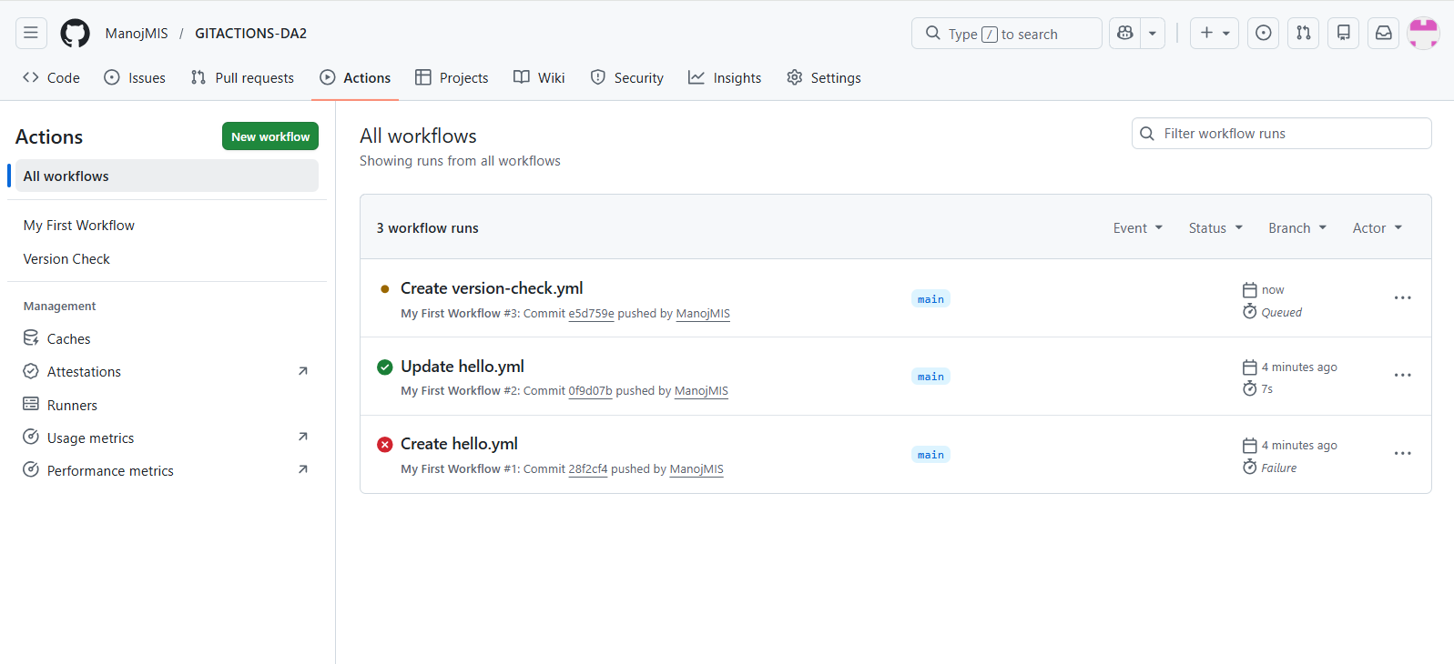

**VERSION AND OUTPUT:**

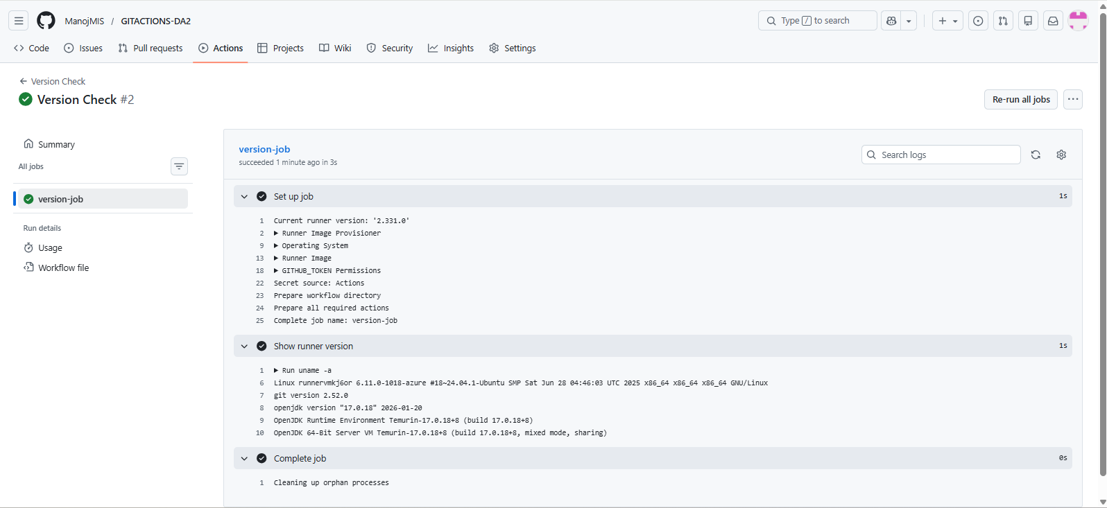

**2.)First Freestyle job created and Output:**

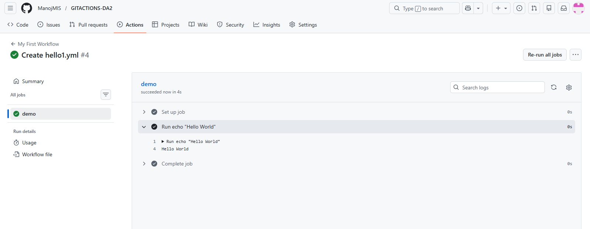

3.)**Text File Created:**

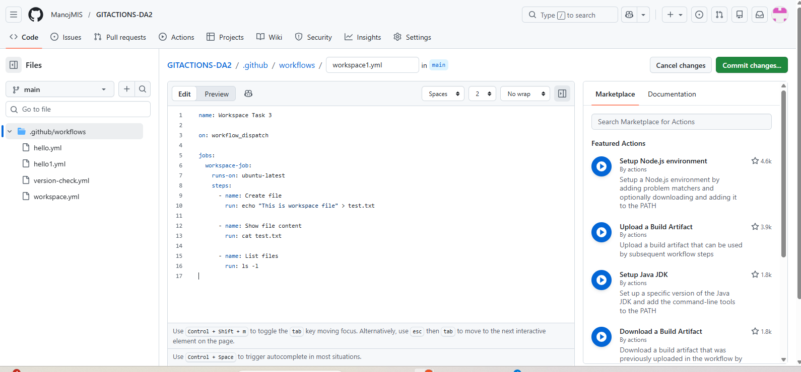

**Job Workspace:**

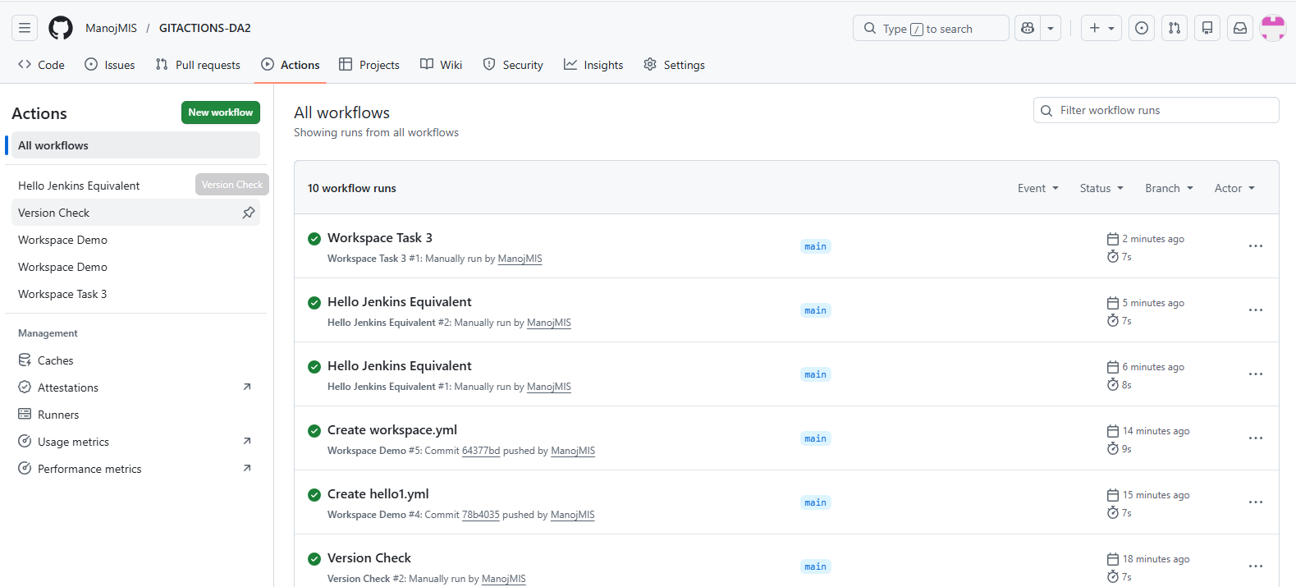

**OUTPUT:**

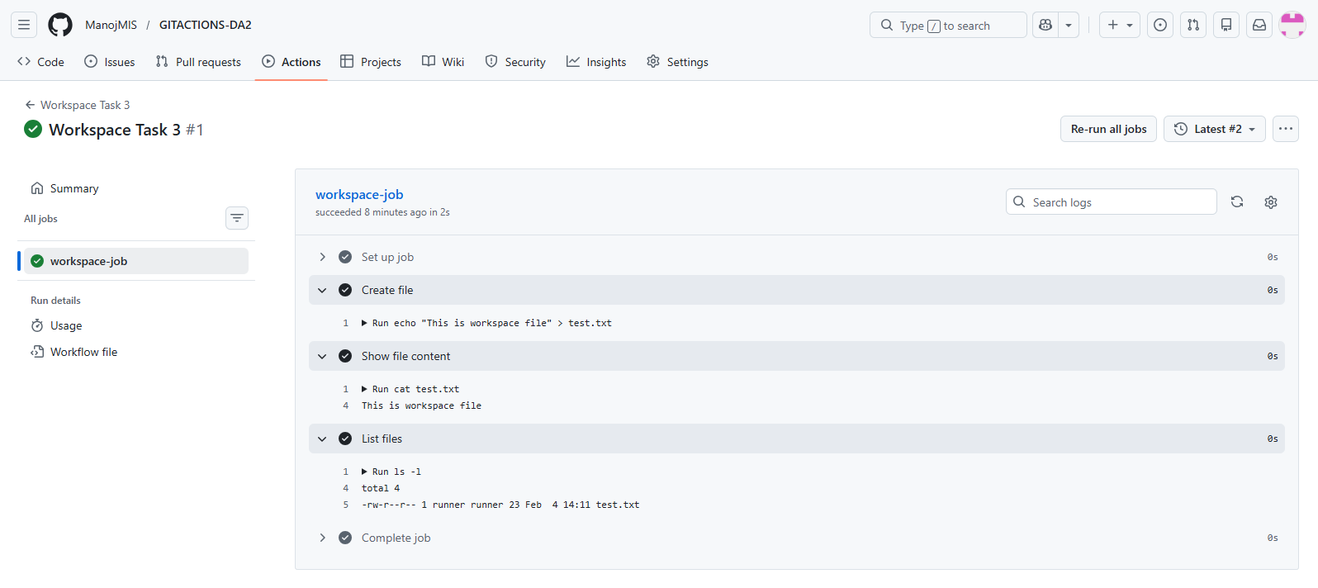

4.)**Git Integration Workflow created:**

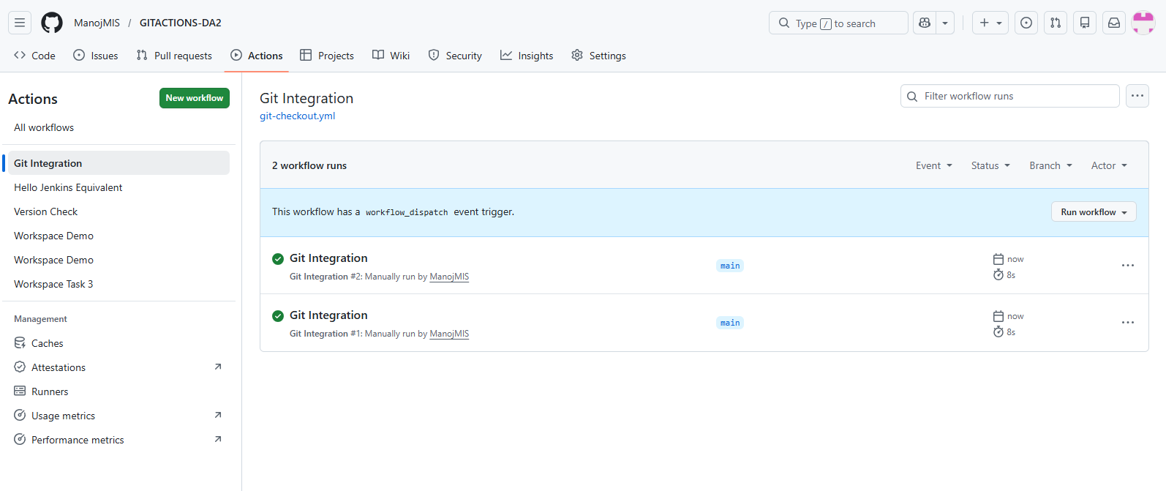

**OUTPUT:**

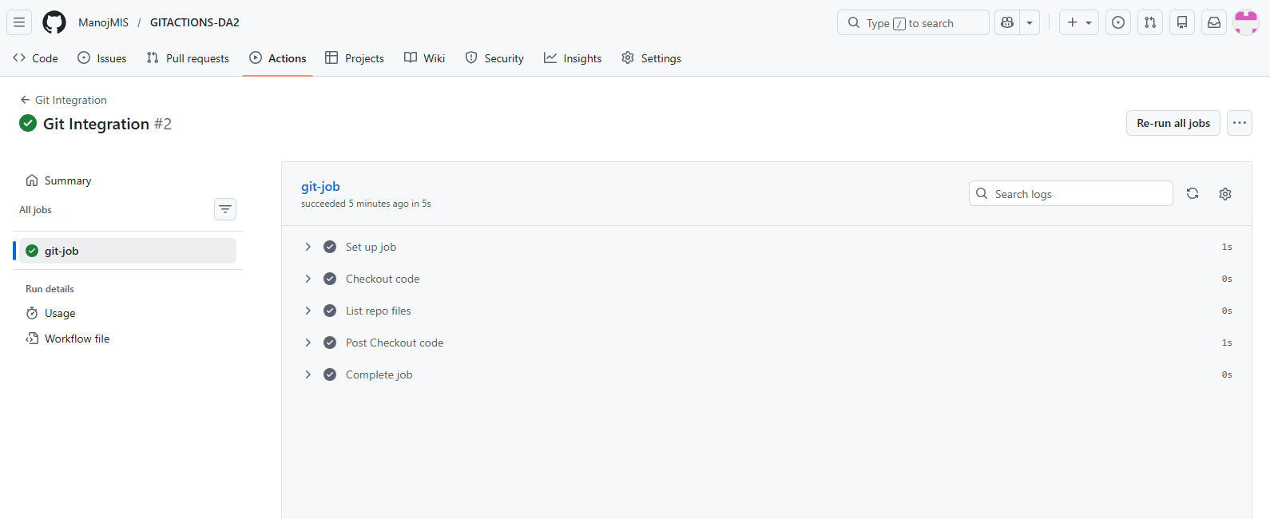

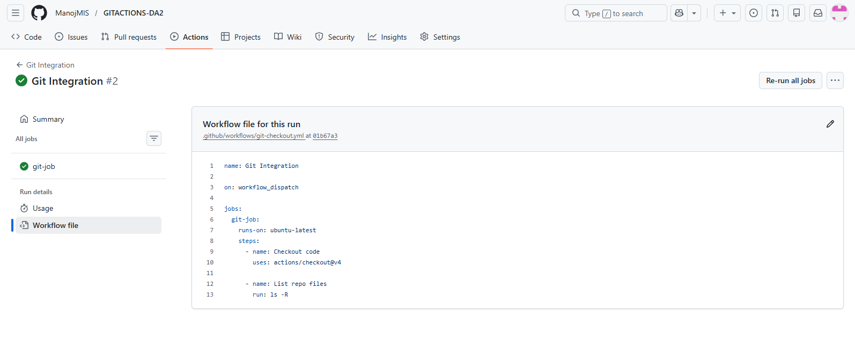

5.)**Auto Trigger Workflow created:**

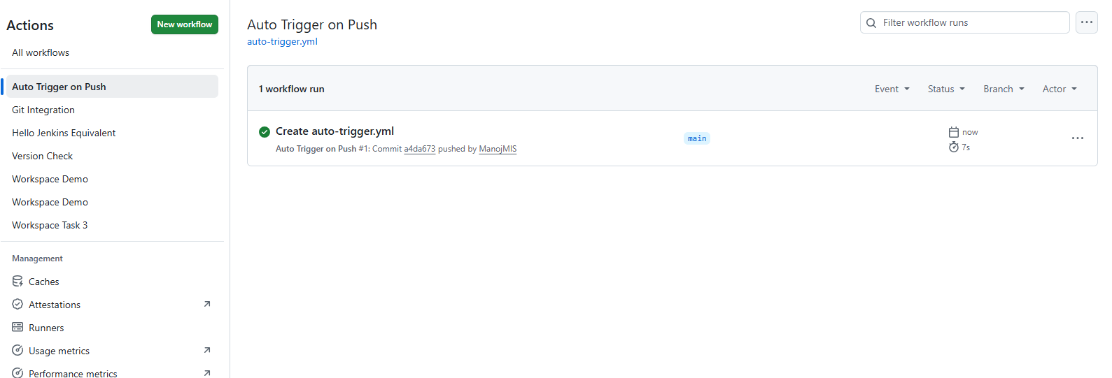

**OUTPUT:**

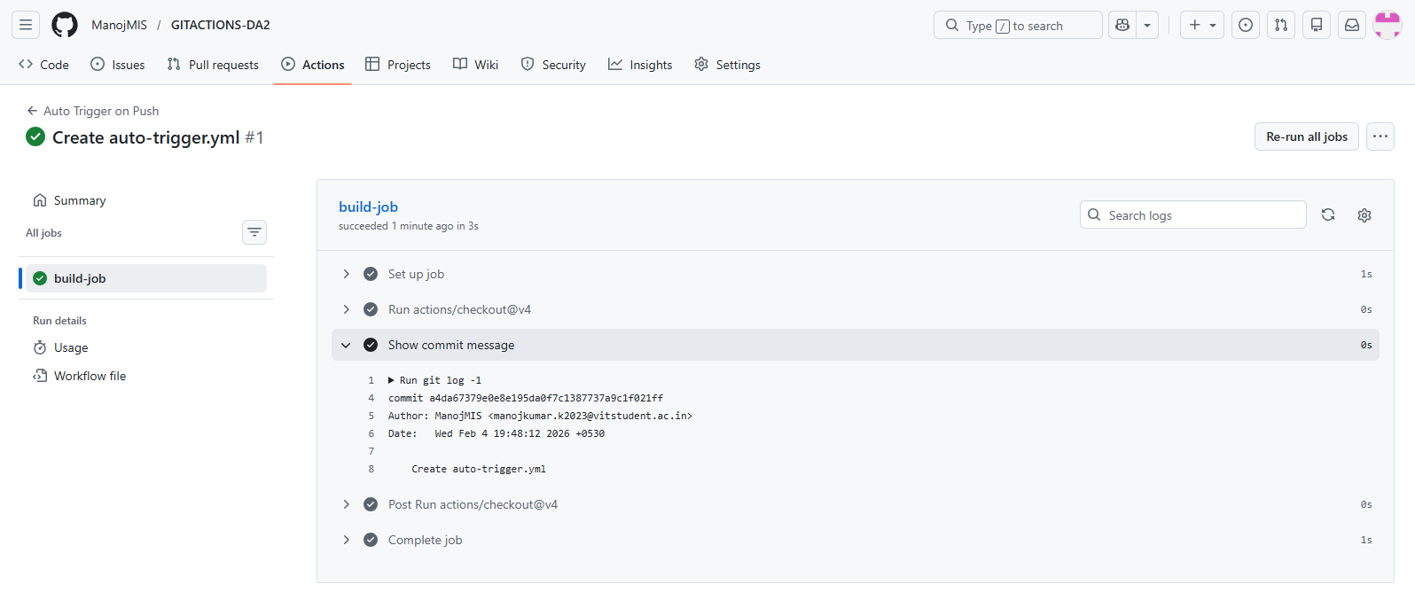

6.)**Parameterized Workflow Created:**

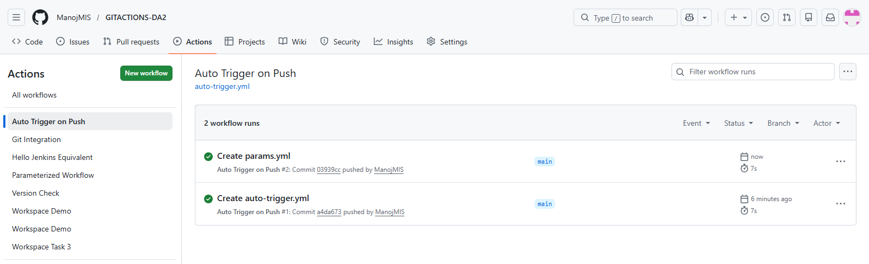

**OUTPUT:**

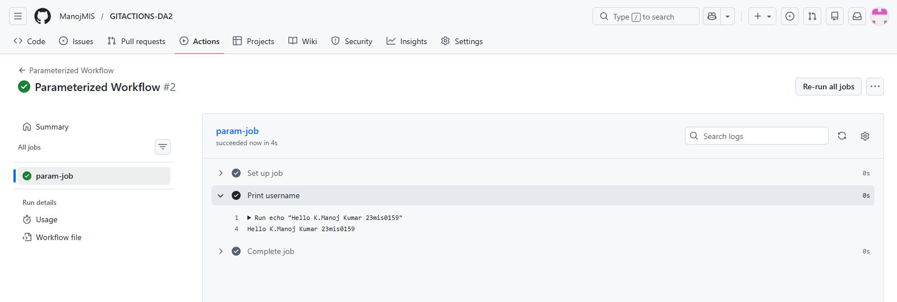

7

7.)**Hello.java FILE:**

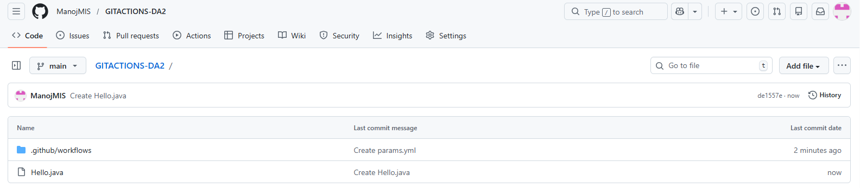

**JAVA workflow created:**

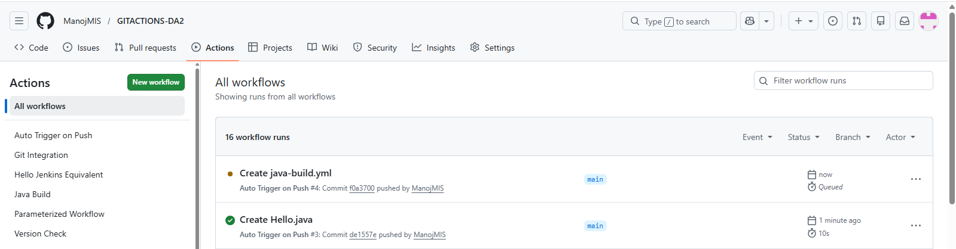

**OUTPUT:**  
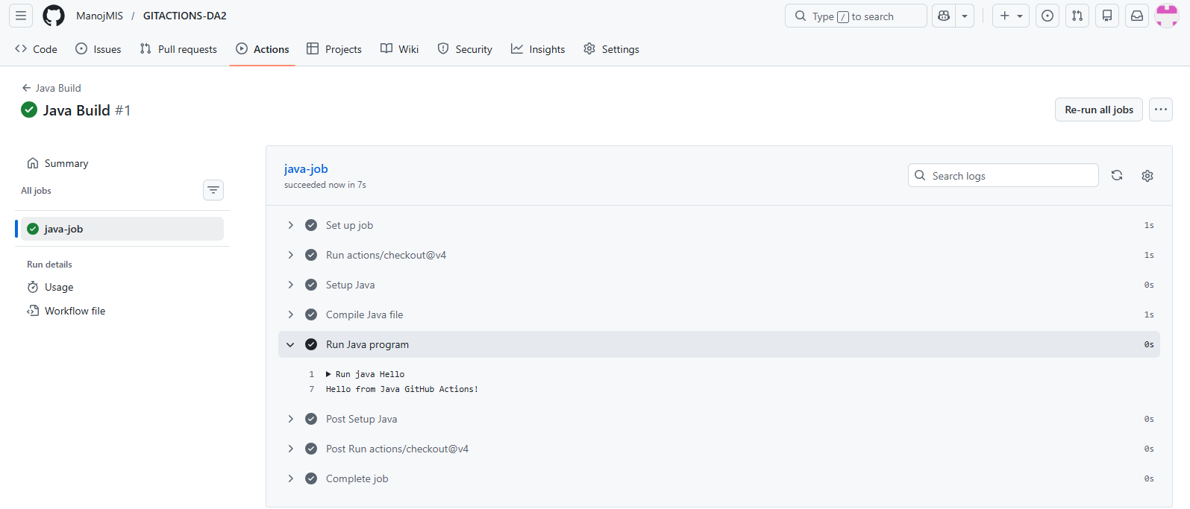

**8.)Artifacts workflow Created:**

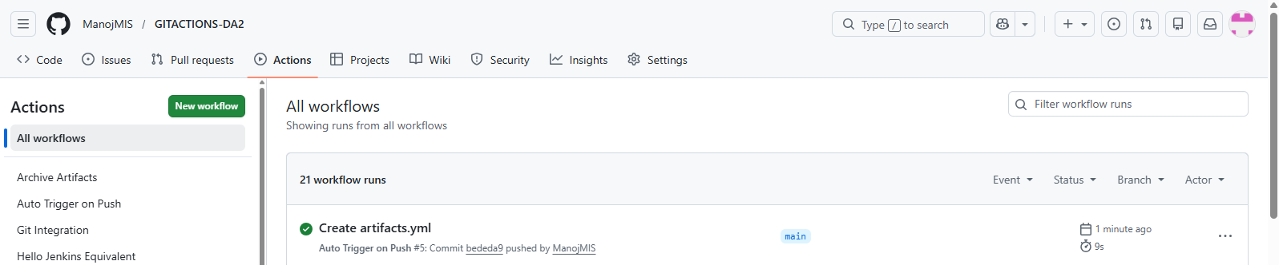

**OUTPUT:**

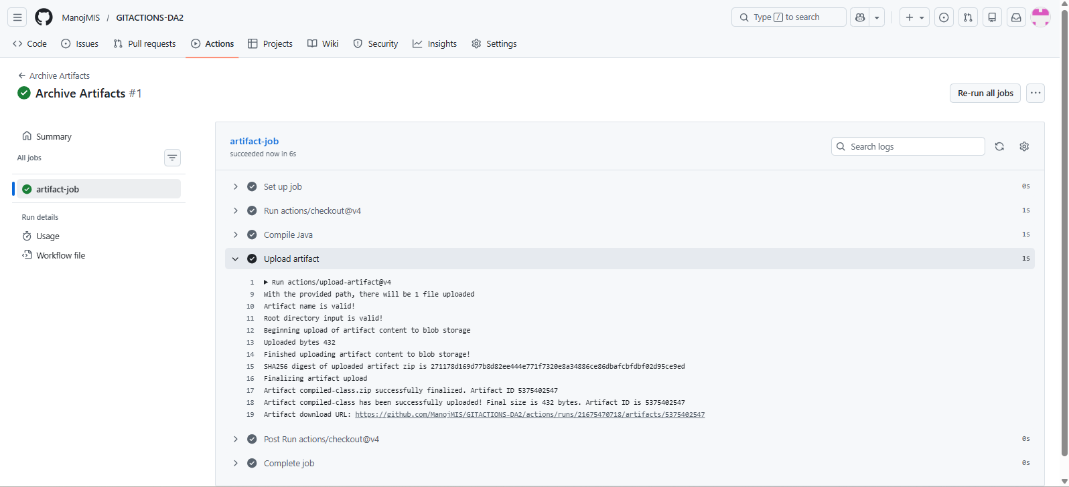

**9.)GIT USERS:**

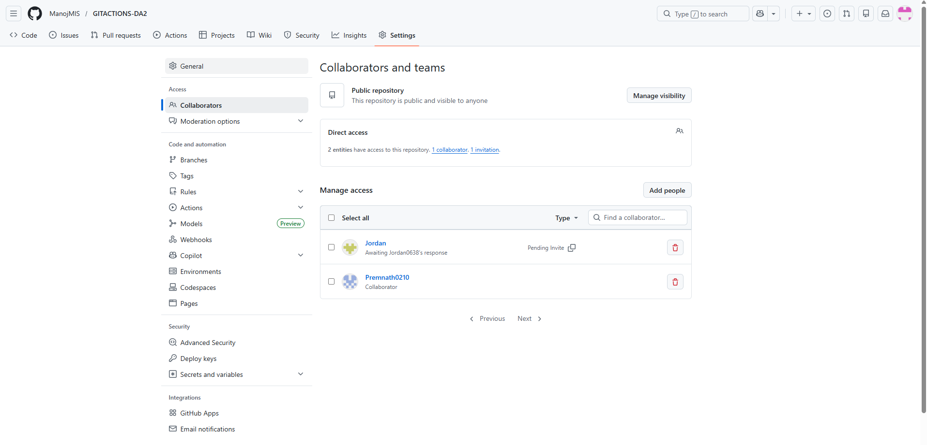

10.)

**Pipeline workflow created:**

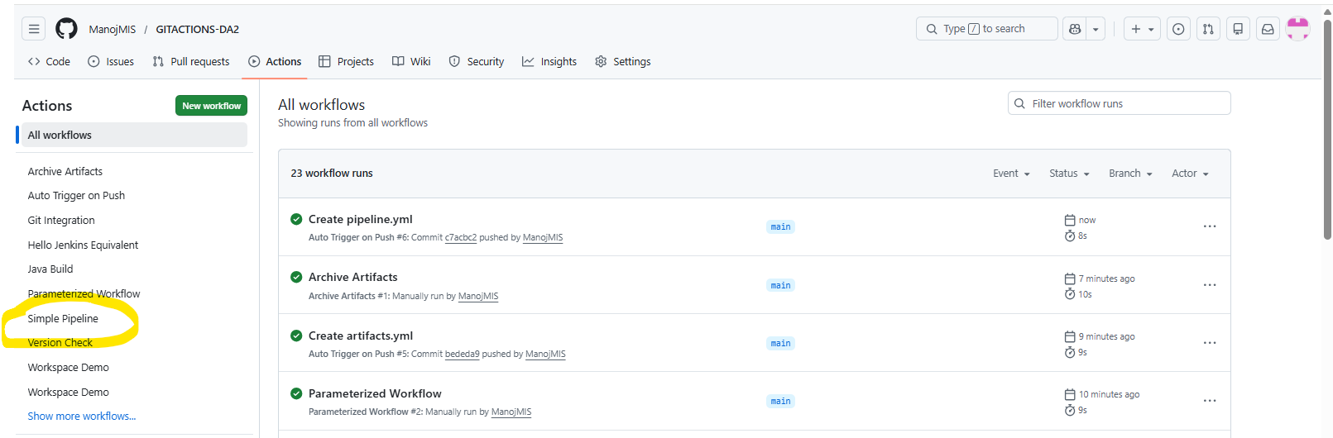

**OUTPUT:**

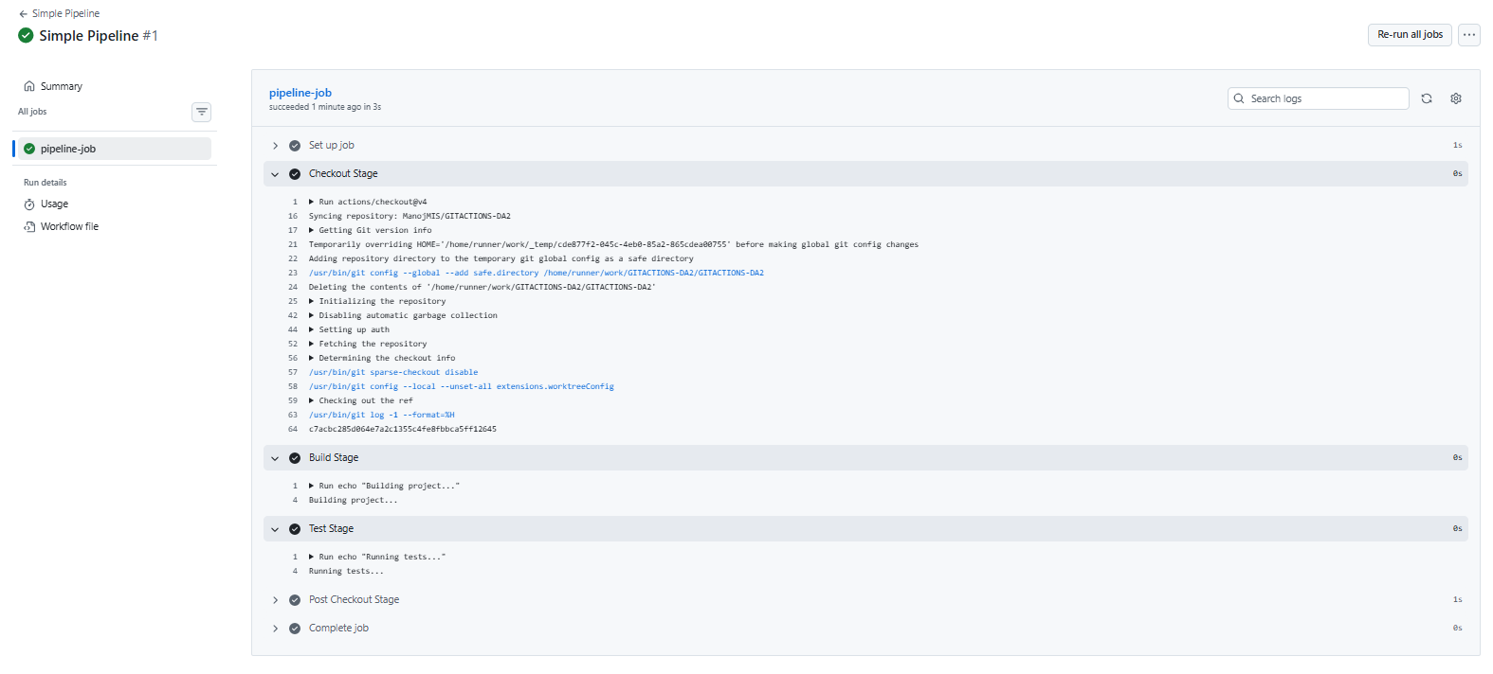

11.)

**Pipeline from GIT workflow created:**

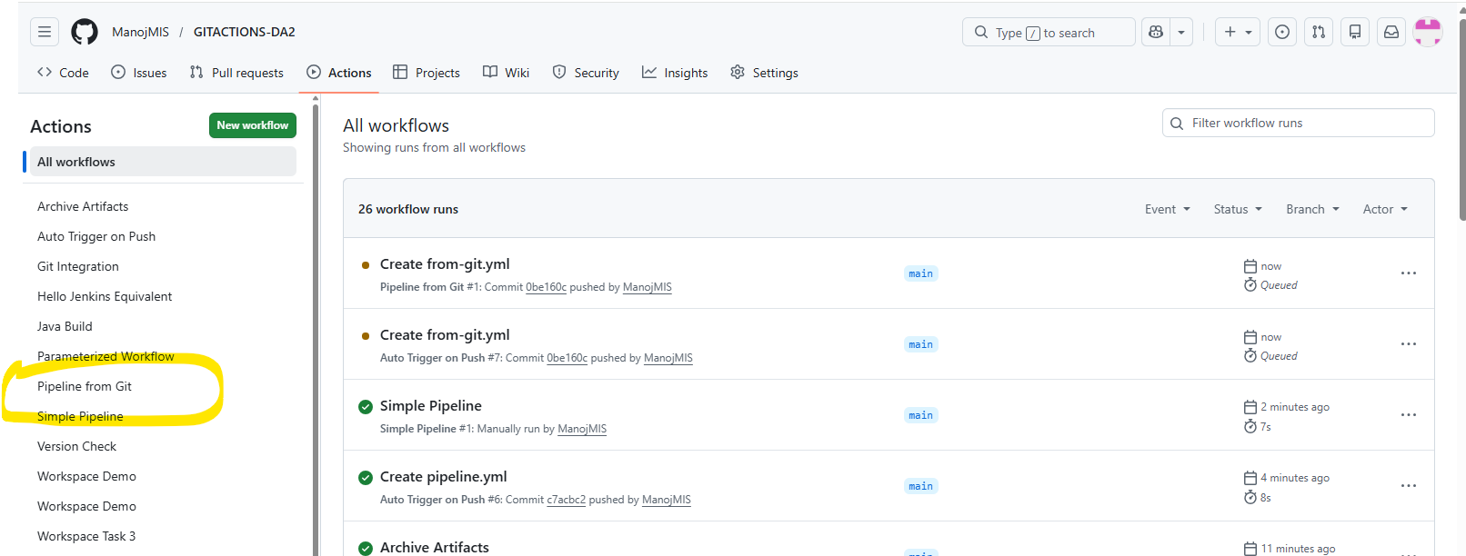

**OUTPUT:**

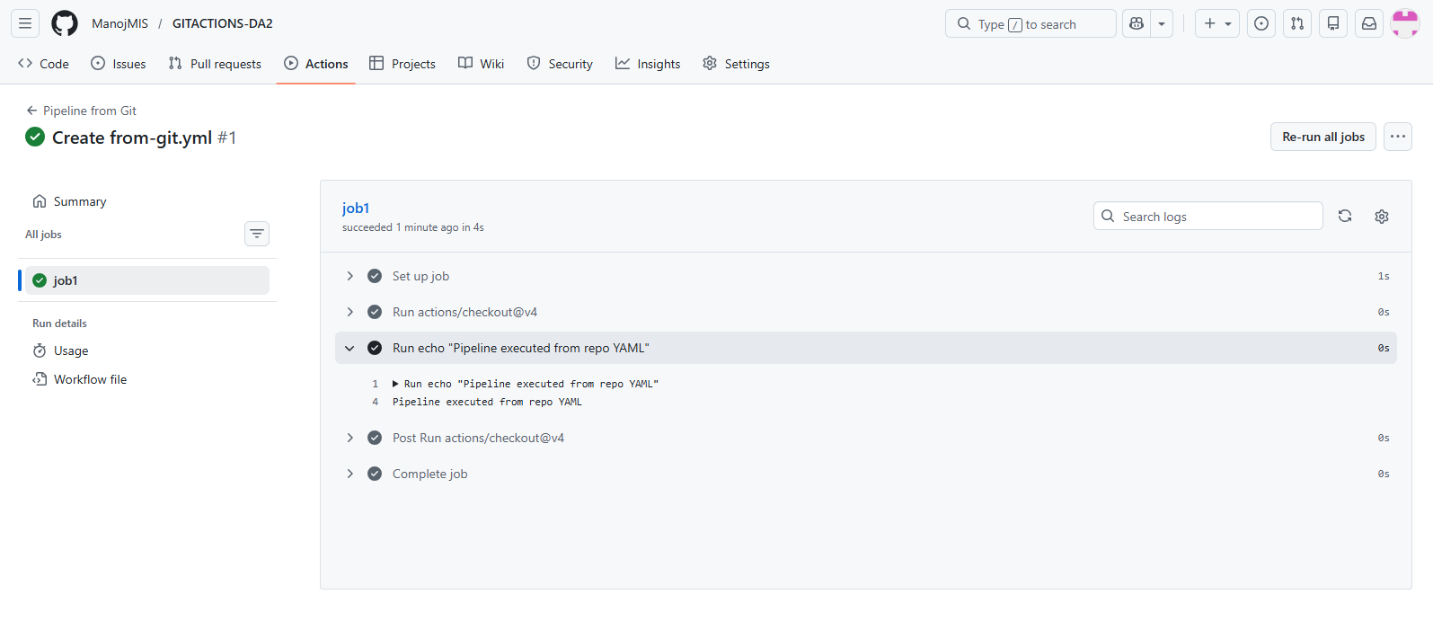

12.)

**Post-build workflow created:**

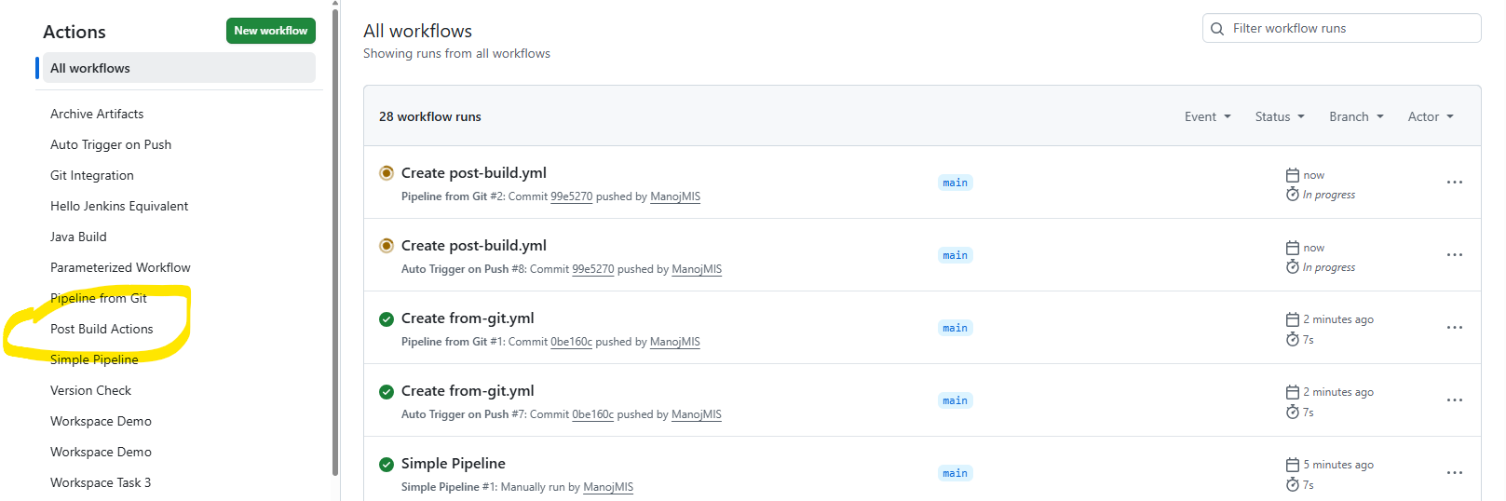

**OUTPUT:**

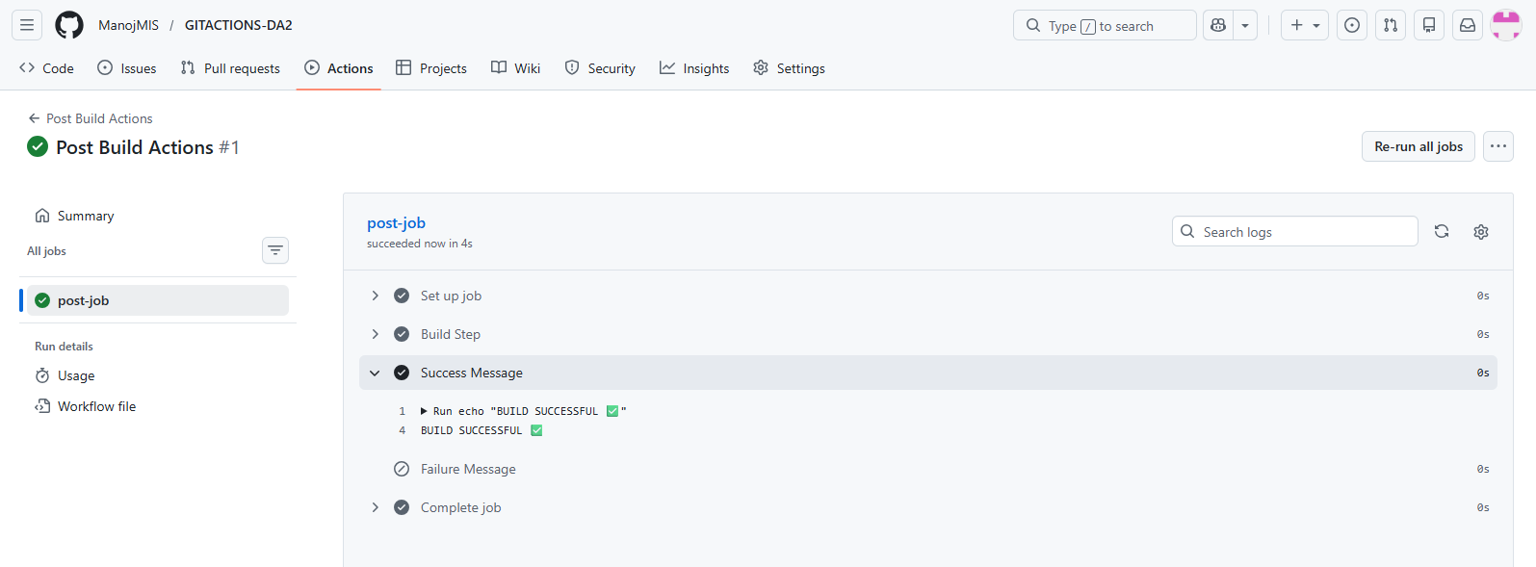

13.)

**Chaining workflow created:**

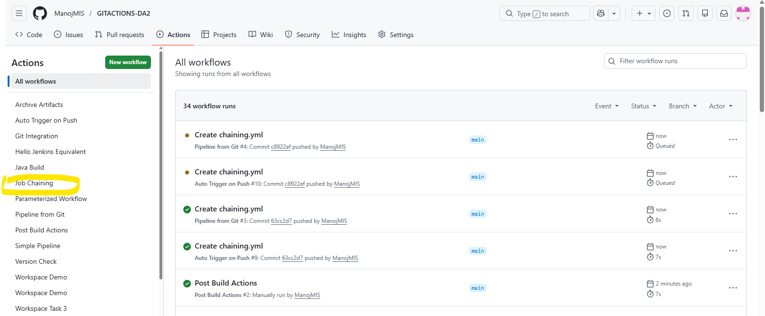

**OUTPUT:**

**JOB-A:**

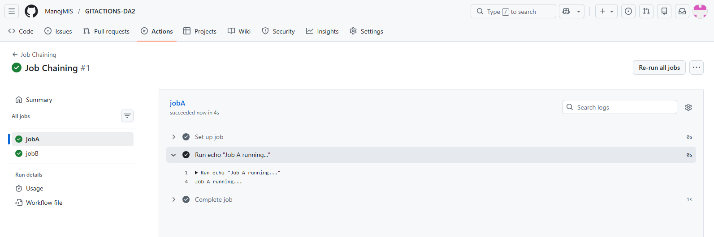

**JOB-B:**

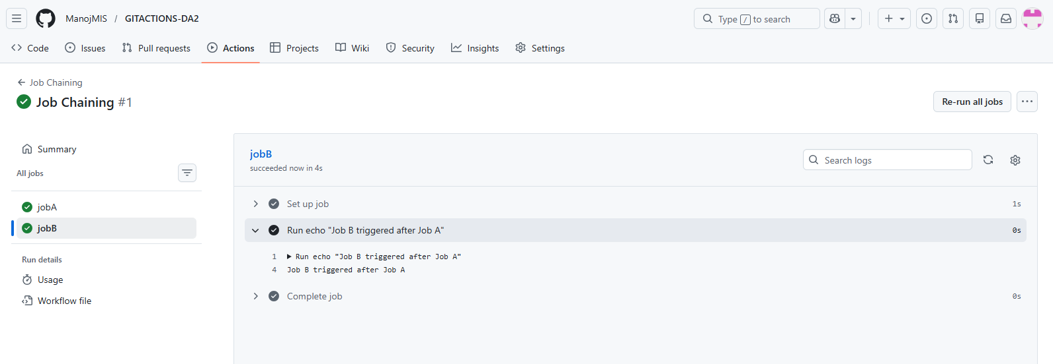

14.)

**Cleanup Workflow created:**

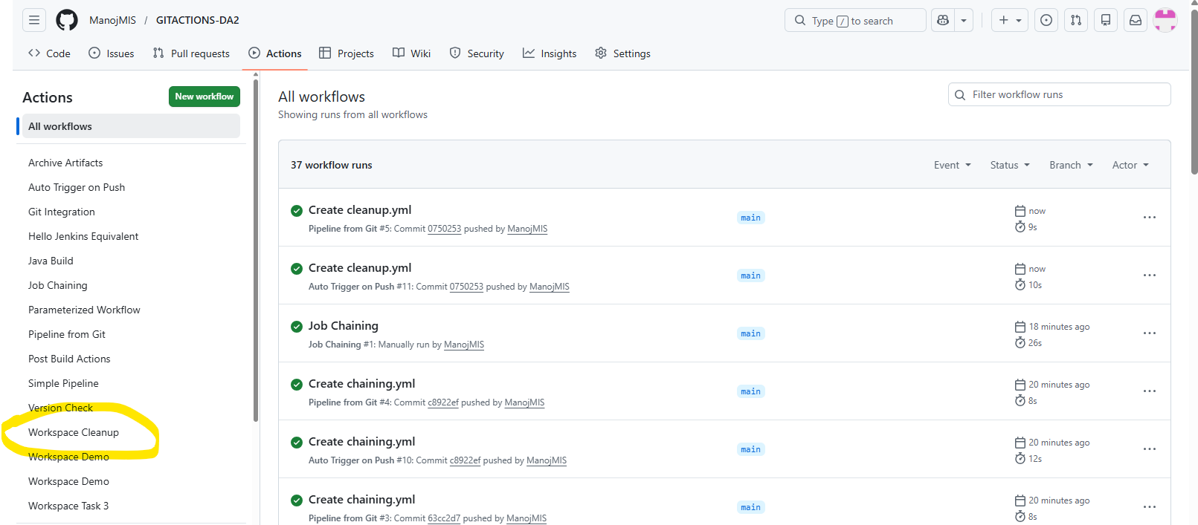

**OUTPUT:**

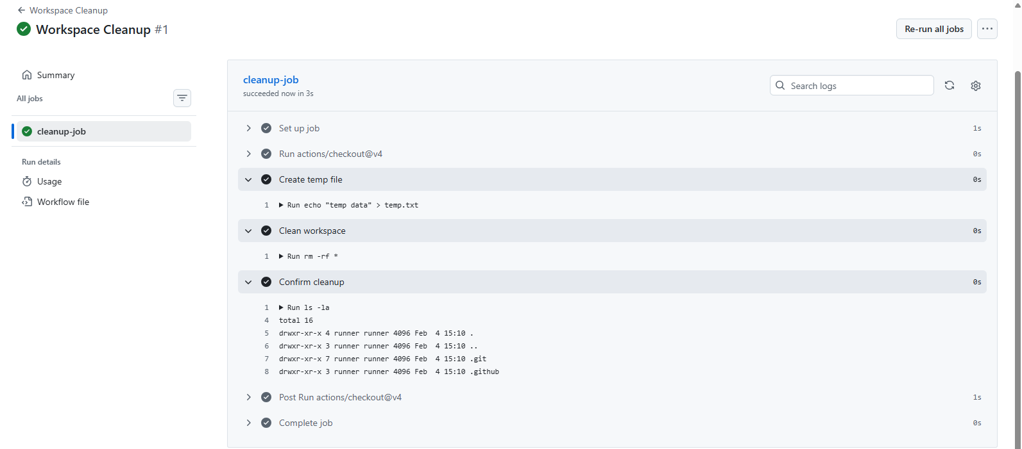

15.)

**CI workflow created:**

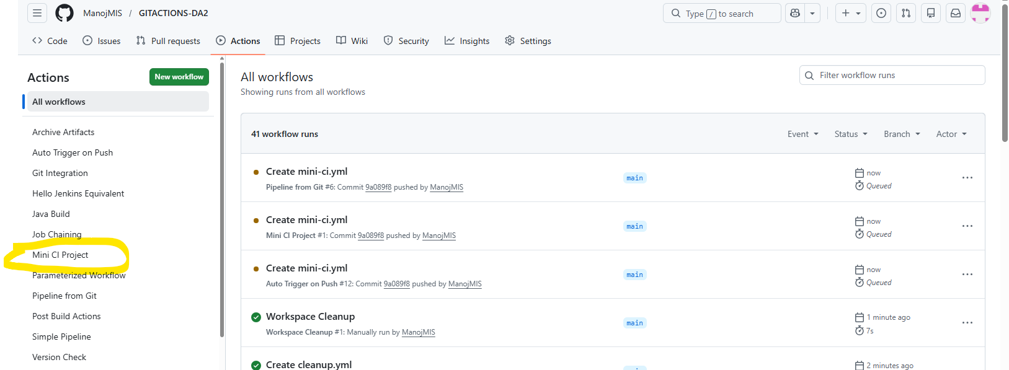

**OUTPUT:**

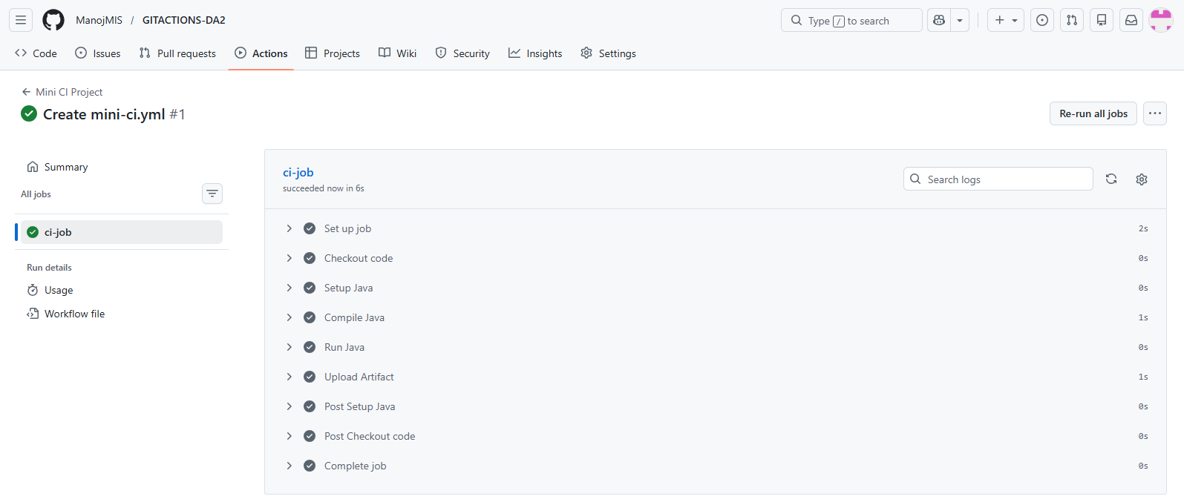

**ALL THE WORKFLOWS CREATED:**

